Webinars

Monday 6th July
- 8.00pm BST:
Deely Sport Science: High Performance Coaching
Ross Bennet: Head of Academy Sport Science (QPR) / Head of Performance (DSS)
Joe Coulter: Head of Operations (DSS)

REGISTER HERE FOR FREE - https://buff.ly/2YYyqJo

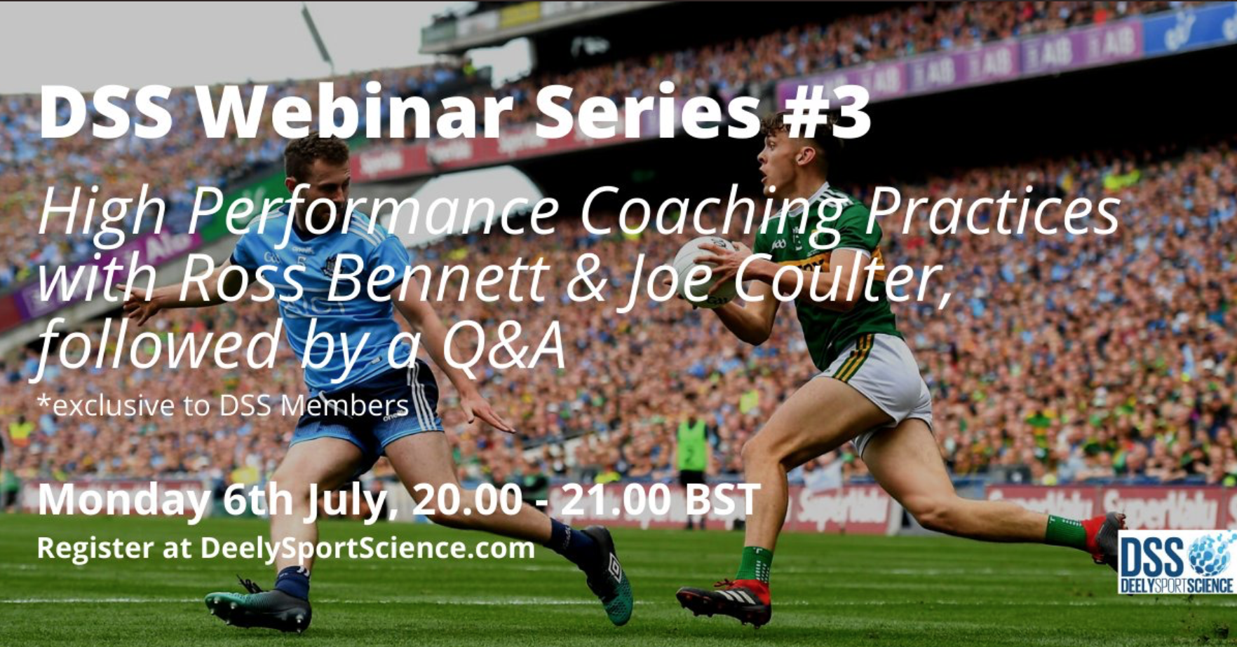

Webinars

Tuesday 7th July
- 1:30pm BST:
Munster Rugby Webinar Series
Session One - Return to Rugby: How participation events can re-open your club and re-engage your community.

Link to Register:
https://www.munsterrugby.ie/domestic_news/irfu-launch-webinar-series-to-support-volunteers/

- 6:00pm BST:
Local Sport Science and Strength and Conditioning discussion
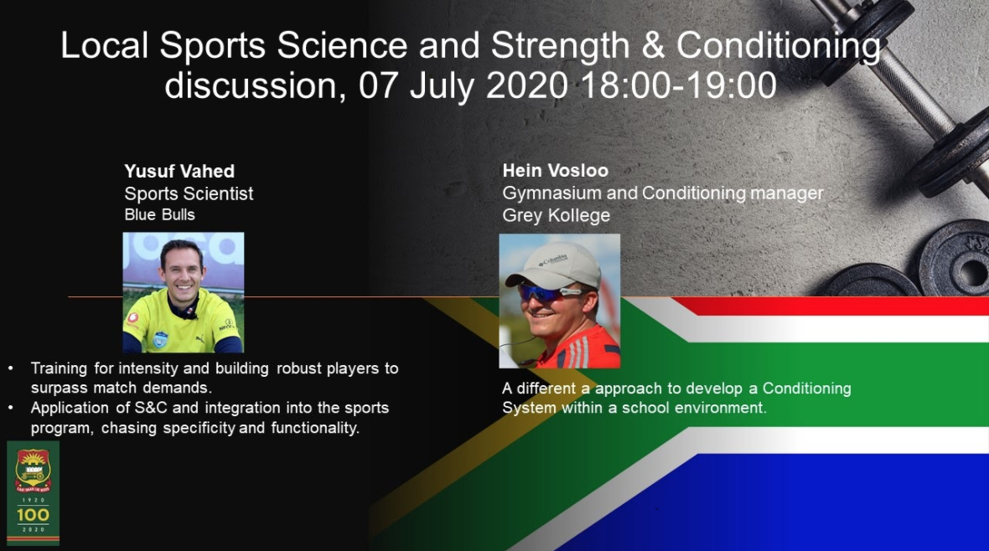

Link to Register: https://docs.google.com/forms/d/e/1FAIpQLSeh5zwqyzswrDo7ki_ha4dyVpKXmJOe3eWGNZ7VOsJF_r8Phw/viewform

Webinars

Wednesday 8th July

- 1:30pm BST:
Munster Rugby Webinar Series
Session Two - Give it a try: Creating a safe and fun environment for girls to learn rugby in clubs.

Link to Register:
https://www.munsterrugby.ie/domestic_news/irfu-launch-webinar-series-to-support-volunteers/

Webinars

Thursday 9th July

- ALL DAY:
The Power Conference: Organised by Zac Woodfin
Jon Gordon (Best Selling Author and Keynote Speaker), Goodie Goodloe (Best Selling Author and Keynote Speaker) Michelle Carter (USA Olympic Shot Putt Gold Medalist), Loren Landow (Head Strength and Conditioning Coach-Denver Broncos), Anthony Blevins (Assistant DB's Coach- New York Giants), Nicodemus Christopher (Director of Athletic Performance-Men's Basketball - University of Missouri) Sonya Woods (Director of Speed, Strength, and Conditioning- Coastal Carolina University),
Michael Chatman (Director of Athletic Performance- Men's Basketball, Stanford University), Greg Adamson (Associate Director of Olympic Sports Performance- University of Tennessee), Ricky Ng (Performance Nutrition Director- Las Vegas Raiders), Aaron Kampman (Former NFL athlete, Founder and CEO of Align), Lewis Caralla (Head Football Strength and Conditioning Coach- Georgia Tech), Liane Blyn (Director of Sports Performance- Olympic Sports, Arizona State University) Gary Cramer )Life Coach, Motivational Speaker, Educator- University of Alabama).

Register here for $10: https://www.eventbrite.com/e/the-power-conference-2020-tickets-94659492089?aff=ebdssbeac

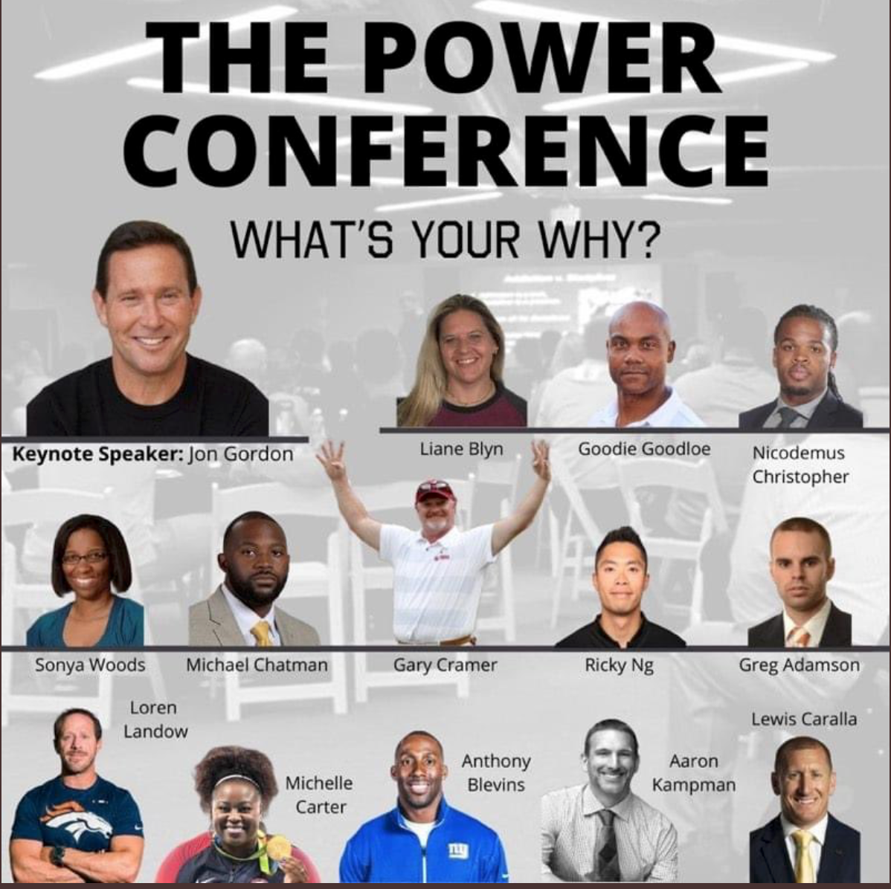

- 1:30pm BST:
Munster Rugby Webinar Series
Session Three - Non contact Rugby: Tag rugby, touch rugby and the lifelong participation for players of all abilities.

- 4:00pm BST:
FIFA Women’s World Cup 2019: Physical development of the women’s game

Link to Register: https://www.fifa.com/womensworldcup/

- 7:00pm BST:
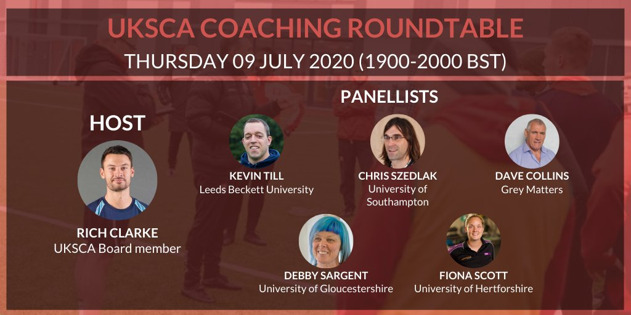
UKSCA Coaching Roundtable

Link to Register: https://survey.sogosurvey.com/survey.aspx?k=SsRRSPQsXXsPsPsP&lang=0&data=

