Webinars

Tuesday 14th July
- 11pm BST:
Zac Woodfin: The Power Conference Day 2
11.15pm: Liane Blyn (Director of Sports Performance- Olympic Sports, Arizona State University)
11.45pm: Anthony Blevins (Assistant DB's Coach- New York Giants),
12.15pm: Michael Chatman (Director of Athletic Performance- Men's Basketball, Stanford University)
12.45pm: Greg Adamson (Associate Director of Olympic Sports Performance- University of Tennessee)
1.15am: Lewis Caralla (Head Football Strength and Conditioning Coach- Georgia Tech)

Register here for $10: https://www.eventbrite.com/e/the-power-conference-2020-tickets-94659492089?aff=ebdssbeac
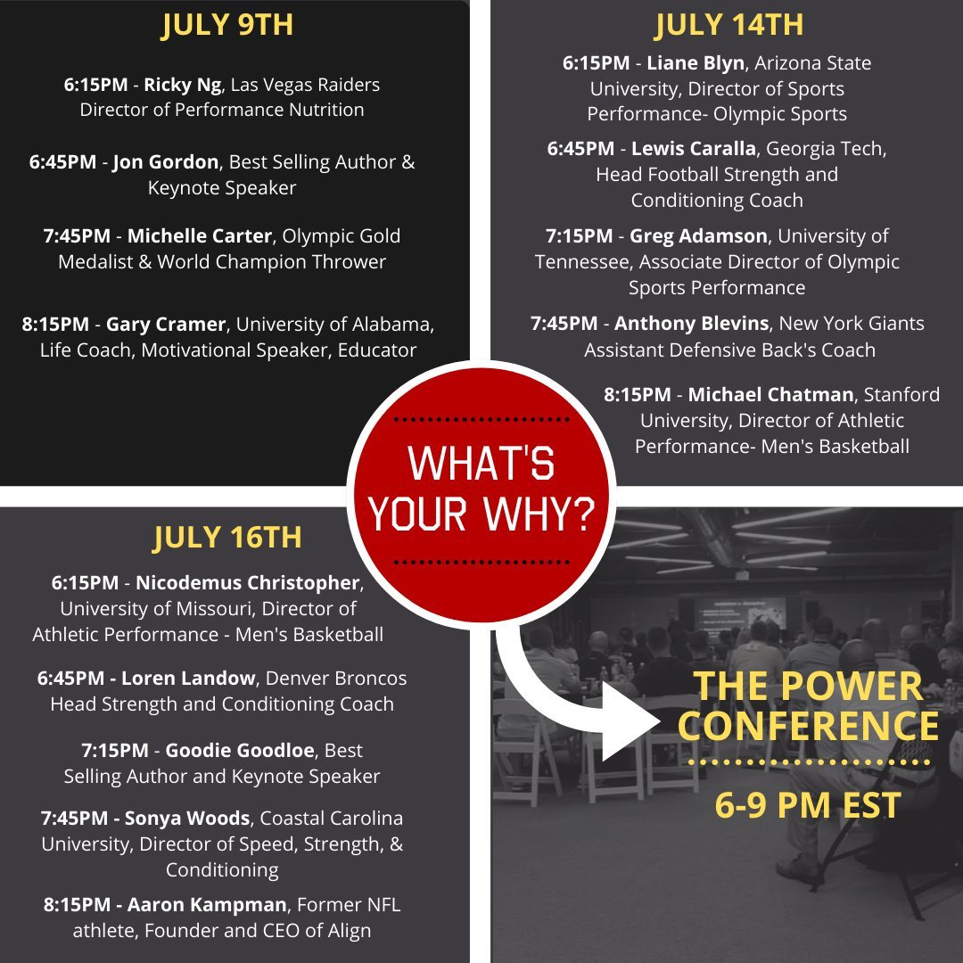
Webinars

Thursday 16th July:

- 7pm BST:
UKSCA: TBC
Register here for TBC

- 8pm BST:
Athletics Northern Ireland: The Science of Running
With Steve Magness (Head Cross Country Coach at University of Houston)

Register here for free: https://www.eventbrite.co.uk/e/athletics-ni-zoom-coach-development-series-steve-magness-tickets-105095457342

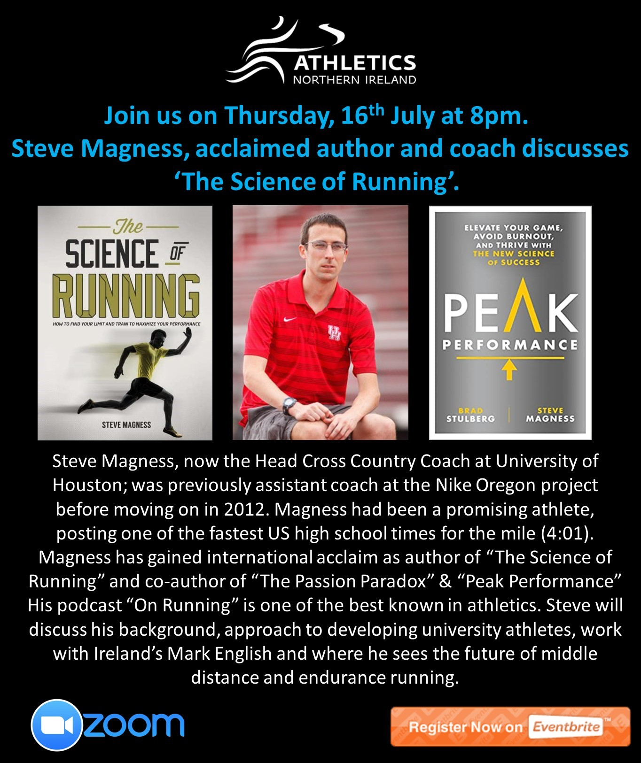

- 11pm BST:
Zac Woodfin: The Power Conference Day 3
11.15pm: Nicodemus Christopher (Director of Athletic Performance-Men's Basketball - University of Missouri)
11.45pm: Loren Landow (Head Strength and Conditioning Coach-Denver Broncos)
12.15pm: Goodie Goodloe (Best Selling Author and Keynote Speaker)
12.45pm: Sonya Woods (Director of Speed, Strength, and Conditioning- Coastal Carolina University)
12.45pm: Aaron Kampman (Former NFL athlete, Founder and CEO of Align)

Register here for $10: https://www.eventbrite.com/e/the-power-conference-2020-tickets-94659492089?aff=ebdssbeac

