Webinars

Monday 8th June
- 4pm BST:
SURPASSPORT: Contact Tracing for Sport
Register here for free: https://t.co/K8ZvGS0imG?amp=1

- 7.30pm BST:
Kildare GAA: Youth/Adult Hurling Coaching Through Small Sided Games
With John Doran & Leon Gordon
https://forms.office.com/Pages/ResponsePage.aspx?id=hrxFrNSvpUKfwz6H4bd_zjI3NlW9Wp9Ggw6Wgc-U4ZpUQ05IUTU0UUlSRzJENElESzFKV1JaSVdSTC4u

Webinars

Tuesday 9th June
- 1pm BST:
Online Sports Nutrition Conference
Hosted by Charles Ashford with
Alannah McKay: Optimizing iron intake for athletes
Lauren Delany: Nutrition in sprint cycling.
Marc Fell: The effects of exogenous carbohydrate provision during prolonged endurance exercise: implications for endurance performance.
Jasmine Campbell: Nutrition support for open water swimmers: in-race fuelling considerations.
Laura Moretti: RED-S
Lisa McDowell: Powering the puck by hardwiring habits of the pro hockey player.
Dr Lindsay MacNaughton: The relationship between lean body mass and protein feeding: the science behind the practice.
Meghan Bentley: Behavior change in sports nutrition
Register here for $20: https://www.eventbrite.co.uk/e/online-sport-nutrition-conference-covid-charity-event-tickets-106118882434

- 7.30pm BST:
GAA Learning Portal Q&A Series: The GAA Player Development Pathway - A new era of player development
With Michael Dempsey & Brian Cuthbert
Register here for free: (https://learning.gaa.ie/gaacoachwebinar2020)

- 7.30pm BST:
Cricket Ireland: Women and Girls in Cricket
Ali Nolan (Cricket Ireland), Callum Atkinson (Northern Cricket Union), Isobel Joyce (Cricket Leinster), Kathryn Rough (North West Cricket Union)
Register here for free: https://us02web.zoom.us/webinar/register/WN_V_HFi2aZTfiHhJde8j5a3Q

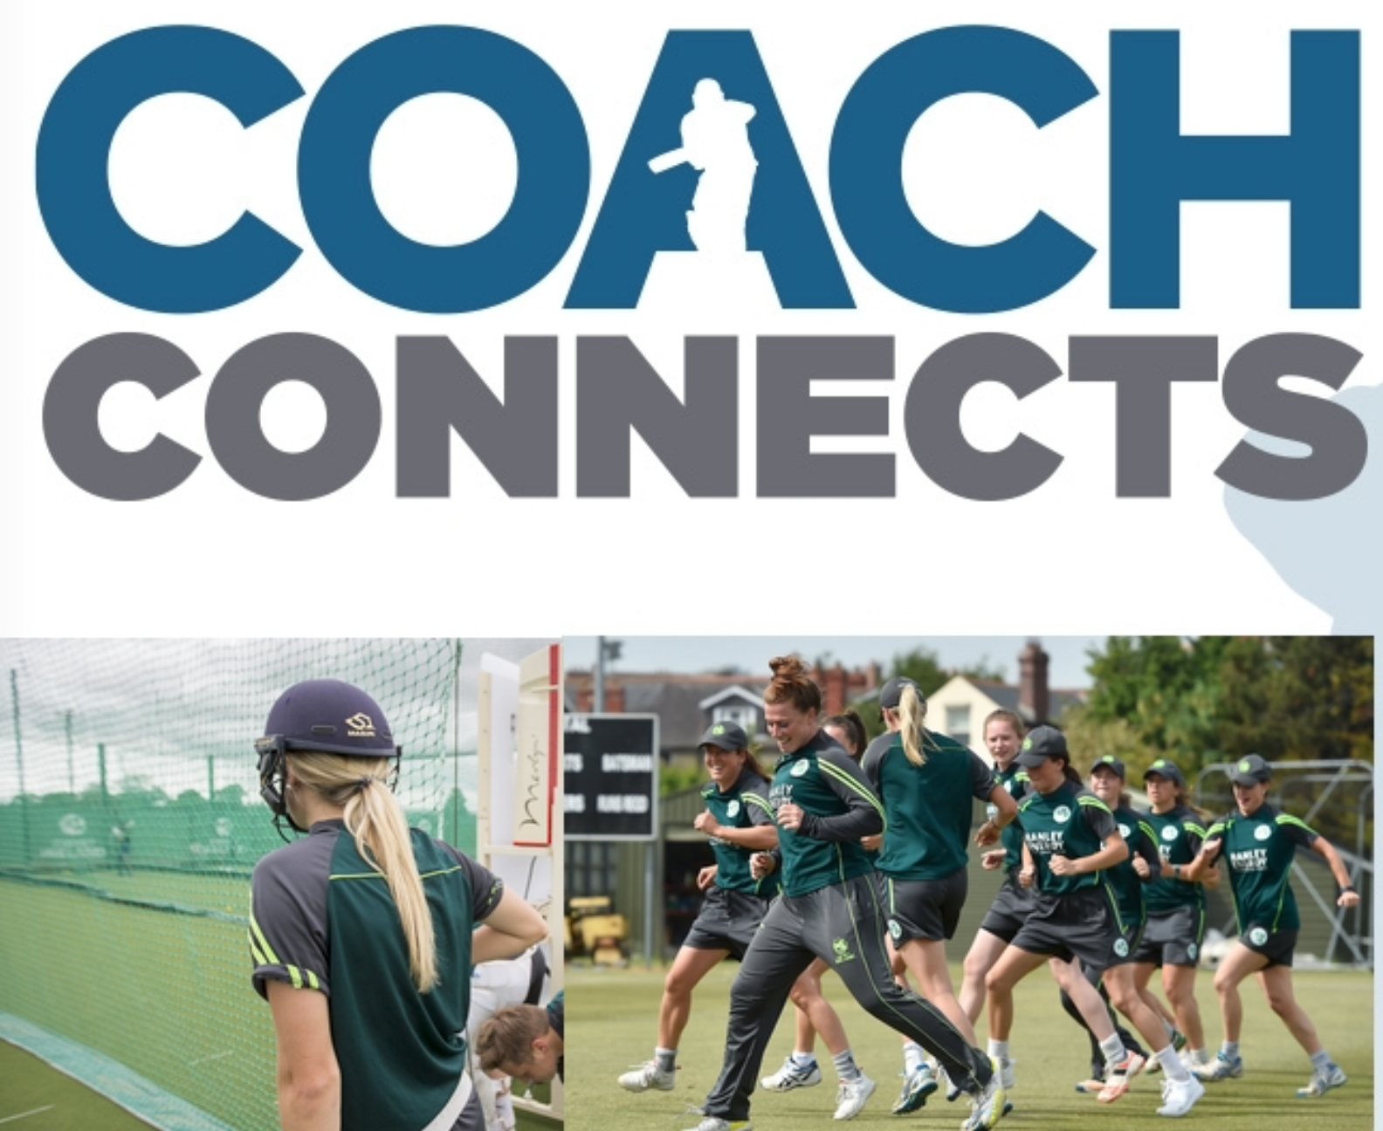

Webinars

Wednesday 10th June
- 9am BST:
Rehab in Sport for S&C Coach: Aidan Oakley
Gav Pratt & Paul Holmes (UFC PI Shanghai) - UFC Rehab process
Darren Burgess (Melbourne Dragons) - Managing the rehab process
Sue Mayes (Australian Ballet) - Foot Function
Simon Harries (GSW Giants) - ACL
Chris Pappas and Ibrahim Kerem (Sydney FC) - Integrated RTP
Myles Murphy (Edith Cowan University) - Latarjet shoulder reconstruction
Luke Vella (Edinburgh Rugby) - Achilles tendon
Emidio Pacecca (New England Patriots) - Calf injuries
Matt Jordan (Canadian Sport Institute) - ACL
Register here for $30: https://t.co/YCxbTemJQH?amp=1

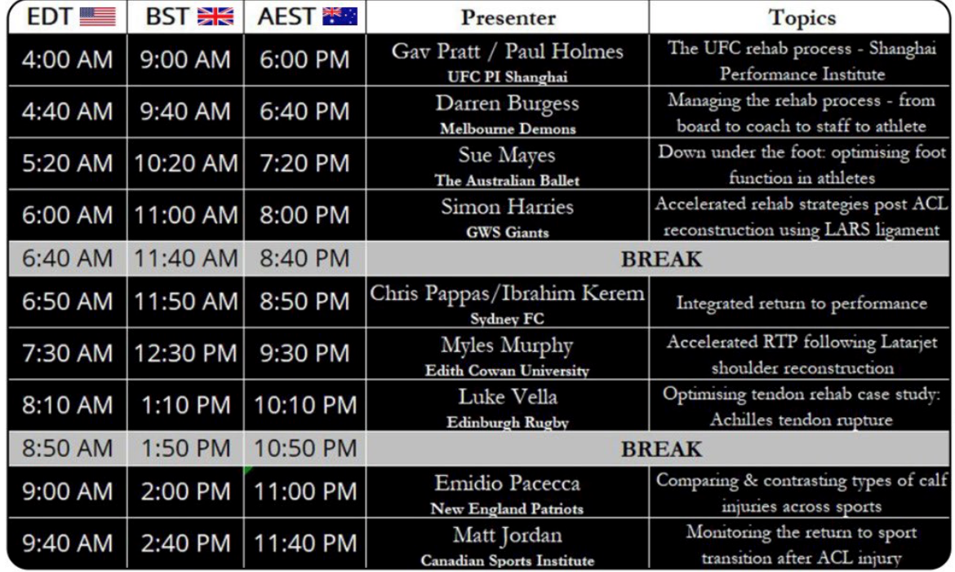

- 1pm BST:
Online Sports Nutrition Conference: Charles Ashford
Chris Rosimus - Fuelling football
Charles Ashford - Lesson learnt from working overseas
Dr Matt Frakes - Nutrition on concussion recovery
Abigail O’Connor - Nutrition and the American Football student
Dr Kelly Hammond - TBC
Dr Shawn Arent - Optimising the high level athlete
Dr Liam Anderson - Fuel for the English premier league
Marcus Hannon - Premier league academy soccer players
Register here for £20: https://www.eventbrite.co.uk/e/online-sport-nutrition-conference-covid-charity-event-tickets-106118882434

- 2pm BST:
iCoachKids - Growth and Maturation in sport
Prof Joe Eisenmann and Dr Sean Cumming
YouTube: https://t.co/oZ9a9Zz8Nn?amp=1

- 8pm BST:
Dublin GAA: Parents Coaching their Children
Naoise Waldron & Damien
Register here for free: https://coaching.dublingaa.ie/coach-referee-education

Webinars

Thursday 11th June:
- 7pm BST:
UKSCA: Facility Ownership and Self-Employment Round Table
Rich Clarke (UKSCA), Mike Young (Athletic Lab), Dave Cripps (TrTennacious and Coalition Performance), Simon Brundish (StrengthLab), Neil Parsley (Underground training station), Teleri Hamilton (Functional Intelligent training).

Register here for free: https://t.co/kEwIadm4wy?amp=1
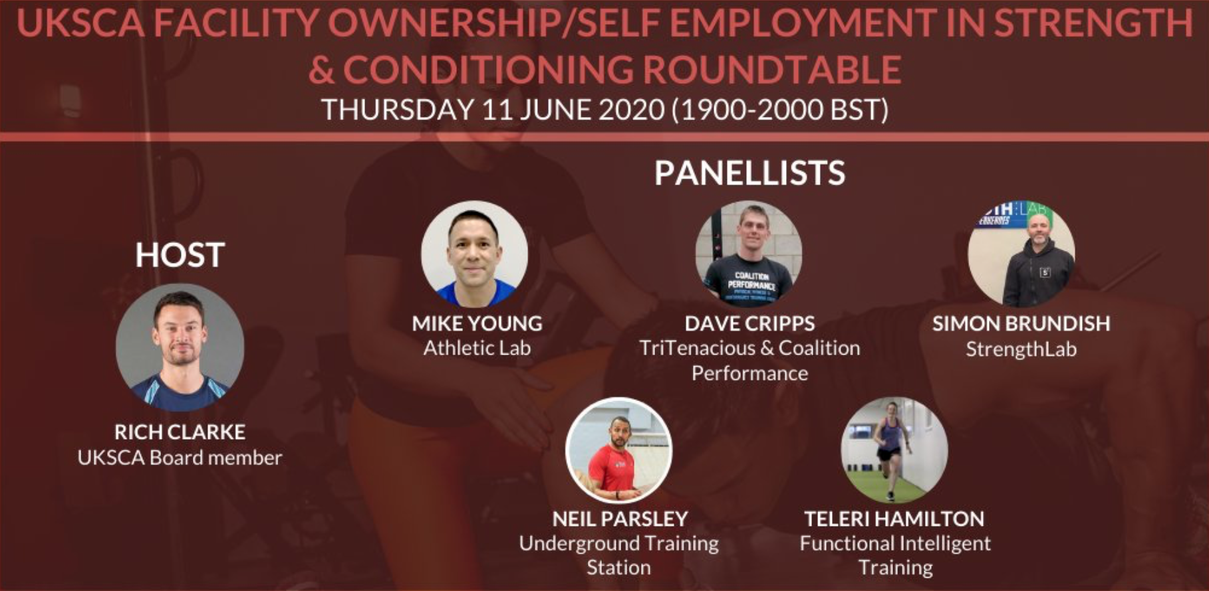
- 7:30pm BST:
GAA Learning: Q&A Series with Barry Horgan

Register here for free: https://learning.gaa.ie/gaacoachwebinar2020

Webinars

Saturday 13th June:

- 11am BST:
Cogbeh Services: The Conscious Athlete
Fergus McGrath (Founder of Cogbeh)

Register here for €33: https://www.eventbrite.ie/e/the-conscious-athlete-1-tickets-108024636596

