Webinars

Monday 29th June

- 7.00pm BST:
LGFA: Effective Coaching Practices for Gaelic4Mothers&Others

Register here for free: https://forms.office.com/Pages/ResponsePage.aspx?id=hrxFrNSvpUKfwz6H4bd_zm8acX0IqvBPoJE4xRsVwk9URE40OThBVFpPUko3VUFHTUY2TTFMNTFCMi4u

- 7.30pm BST:
Kildare GAA: Coaching and games webinar series
Guidelines to Foundation Course Online Registration and GAA Activity
Planner

Register here for free:
https://forms.office.com/Pages/ResponsePage.aspx?id=hrxFrNSvpUKfwz6H4bd_zjNlW9Wp9Ggw6Wgc-U4ZpUQ05IUTU0UUlSRzJENElESzFKV1JaSVdSTC4u
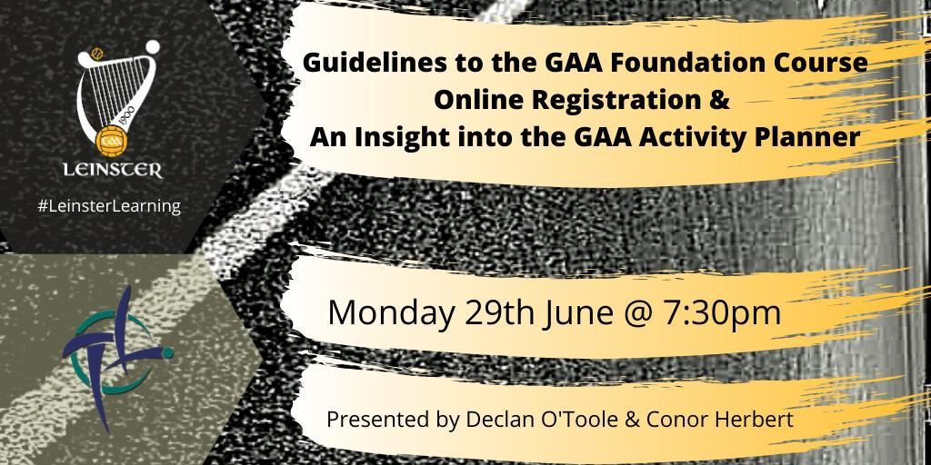

Webinars

Tuesday 30th June
- 7.00pm BST:
Manisha Taylor MBE: Tackling Mental Health Stigma in South Asian Communities
Sabrina Dale (Trainee Sport Psychologist), Vina Bhabhani (Lvl 4 PT).

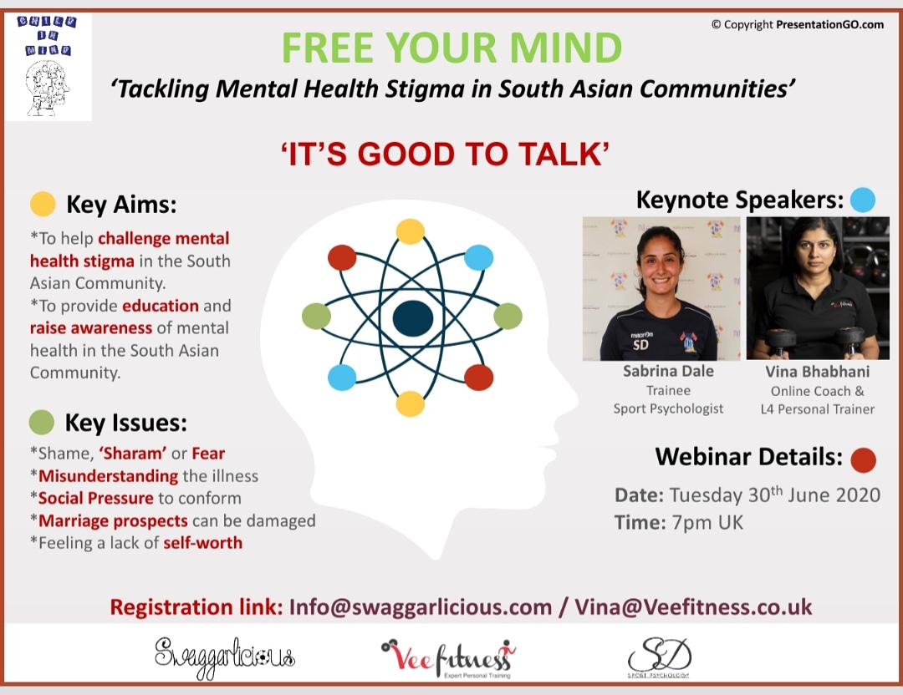
Register here for free: Email info@swaggarlicious.com

Webinars

Thursday 2nd July
- 8pm BST:
Athletics NI: Junior to Senior Transitions in Middle Distance
Trevor Painter, Jenny Meadows, Bill Foster

Register here for free: https://athleticsni.org/News/Athletics-NI-News/Athletics-NI-Zoom-In-To-Coach-Development

Webinars

Friday 3rd July:

- 8.35am BST:
Evert Verhagen: Injuries are the best teachers: How Do Athletes Cope With Injury & What This Means For Optimal Care

Caroline Bolling (Physiotherapist), Vincent Gouttebarge (Chief Medical Officer, FIFA PRO), Rod Whiteley (Physiotherapist at Aspetar Sports Medicine Hospital), Marelise Badenhorst (Post Doc Stellenbosch University)

Register here for free: https://t.co/EhB80AEkuv?amp=1

