Webinars

Monday 22nd June

- 6.30pm BST:
ALTIS - Virtual Apprentice Coach Program Day 1
With Kevin Tyler and Dan Pfaff
Register here once for $99: https://altis.world/product/altis-virtual-acp/

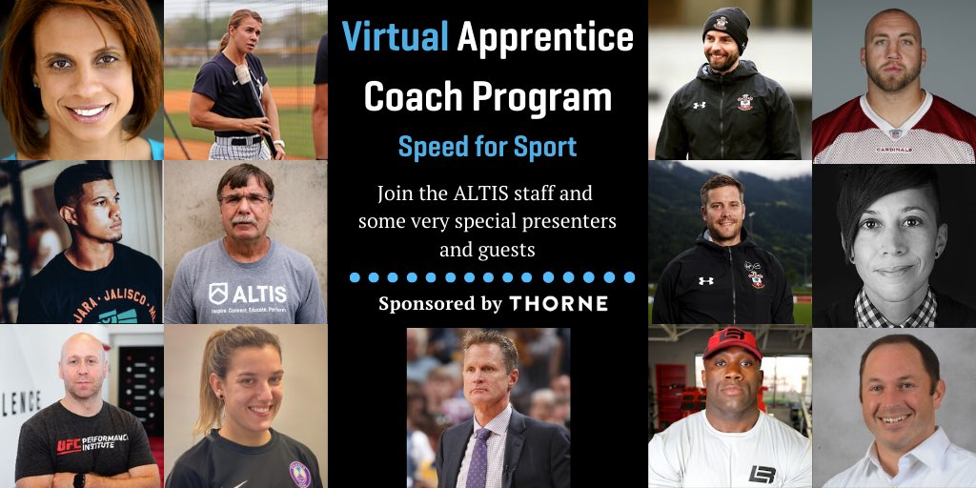

- 7pm BST:
LGFA: Ready Steady Coach: Introduction to Coaching for new coaches
Register here for free: bit.ly/3fF0ZRm

- 7pm BST:
England Rugby: Preparing Players for a Return to Rugby
With Robin Eager (RFU Pathway Athletic Performance Manager) and Tim Hall (S&C Coach, RFU)
Register here for free: bit.ly/3eiEhhH
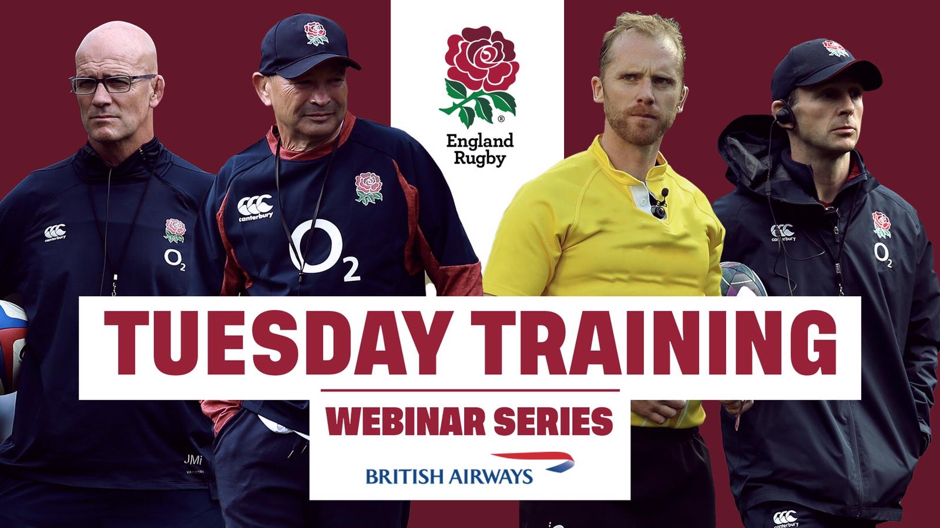

- 7.30pm BST:
Kildare GAA: Coaching the Child
With …
Register here for free: shorturl.at/gosuB

- 7.30pm BST:
Deely Sport Science: From Coach to Athlete – Engaging your Players
With Ciaran Deely (Founder, Deely Sport Science), Cormac O’Beirne (Founder, RYPT), Caoimhe Morris (Head of Education, Deely Sport Science) and Ben Smalley (Sport Scientist, Deely Sport Science).

Register here for free: https://t.co/QiN2I2lsXF?amp=1

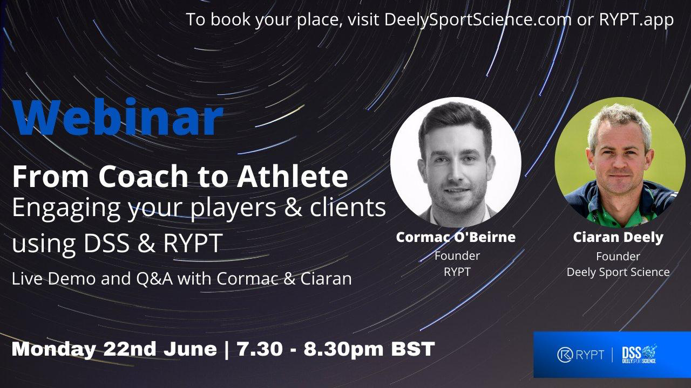

Webinars

Tuesday 23rd June
- 12pm BST:
International Physical Literacy Association (IPLA): How Physical Literacy is or could be influencing practices in the sport & coaching world

With Simon Padley (Vice Chair, IPLA),
Dr Paul Appleton (University of Birmingham),
and Dr Stephen Behan (DCU)
Register here for free: https://t.co/owYS6AAHlo?amp=1

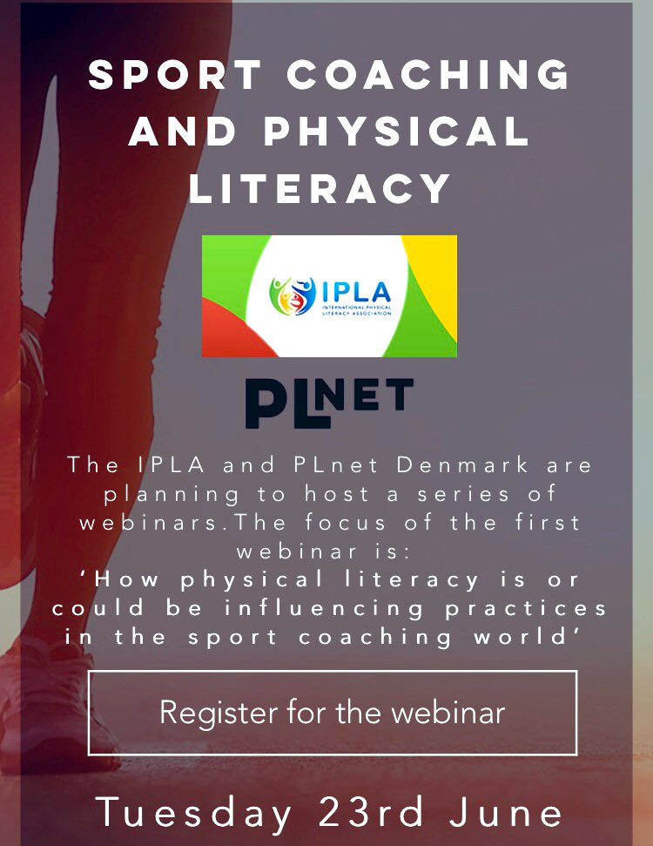

- 6.30pm BST:
International Physical Literacy Association (IPLA): How Physical Literacy is or could be influencing practices in the sport & coaching world

With Simon Padley (Vice Chair, IPLA),
Register here for free: https://t.co/owYS6AAHlo?amp=1

- 6.30pm BST:
ALTIS - Virtual Apprentice Coach Program Day 2
With Dr Jas Randhawa (Lead Performance Therapist, ALTIS),
Dr Ken Clark (PhD Biomechanics | Coach & Researcher in Human Performance) and
Taylor Boggs (Coach & Brand Innovation Director | LB O-line Performance)

Register here once for $99: https://altis.world/product/altis-virtual-acp/

- 6.30pm BST:
Sports Surgery Clinic: Neck Pain
With Dr Ciaran Cosgrove (Consultant Sports & Exercise Medicine Physician SSC & IRFU) and Colm Fuller (Senior Physiotherapist, SSC)
Register here for free: https://sportssurgeryclinic.com/event/online-educational-evening-focusing-on-the-neck/

- 7.30pm BST:
GAA: Return to Coaching
With Martin Fogarty (GAA hurling Development Manager),
Niall Williams (Coach Education Coordinator, Camogie Association) and Stephen O’Shaughnessy (Football Development Officer, Dublin GAA).
Register here for free: https://learning.gaa.ie/gaacoachwebinar2020

Webinars

Wednesday 24th June
- 2pm BST:
ICoachKidsEU: Climate Change in Youth Sports
With Prof Nicolette Schipper-Van Veldhoven (Windesheim University) and Prof Sophia Jowett (Loughborough University)
Register here for free: https://t.co/VYlWujamLS?amp=1
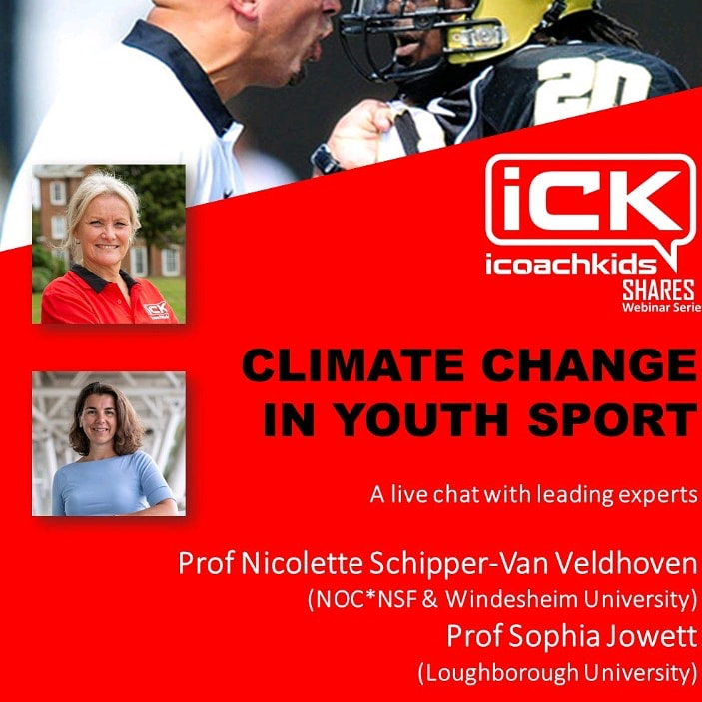

- 6pm BST:
Setanta College: Masters Webinar Series P3: The Future of Performance Coaching

Prof Ian Jeffreys (NSCA, UKSCA, Author), Ron McKeefery (PLAE), Loren Landow (Head S&C Coach, Denver Broncos. Landow Performance), Dr Joe Warne (Setanta College Lecturer).

Register here for free: https://www.setantacollege.com/masters-webinar-2020-india/

Webinars

Thursday 25th June:

- 9:45am BST:
S&C Webinar (Nathan Griffith): Jonas Dodoo - Acceleration and Deceleration (Owner of Speed Works and performance consultant for England Rugby)

To Join head to @Nathangriffithx page on twitter

- 6.30pm BST:
ALTIS - Virtual Apprentice Coach Program Day 2
With Dr. Duncan French (Vice President, Performance | UFC Performance Institute),
Sophia Nimphius (Professor of Human Performance | Edith Cowan University),
Stu McMillan (CEO | ALTIS) and
Les Spellman (Founder | Spellman Performance)
Register here once for $99: https://altis.world/product/altis-virtual-acp/

- 7pm BST:
UKSCA: Monitoring Roundtable
With Rich Clarke (UKSCA), Tom Batchelor (Harlequins), Ibrahim Akubat (Newman University), Shaun McLaren (Sport Science Consultant), Anthony Turner (Middlesex University)
Register here for free: https://survey.sogosurvey.com/survey.aspx?k=SsRRSPQsXVsPsPsP&lang=0&data=

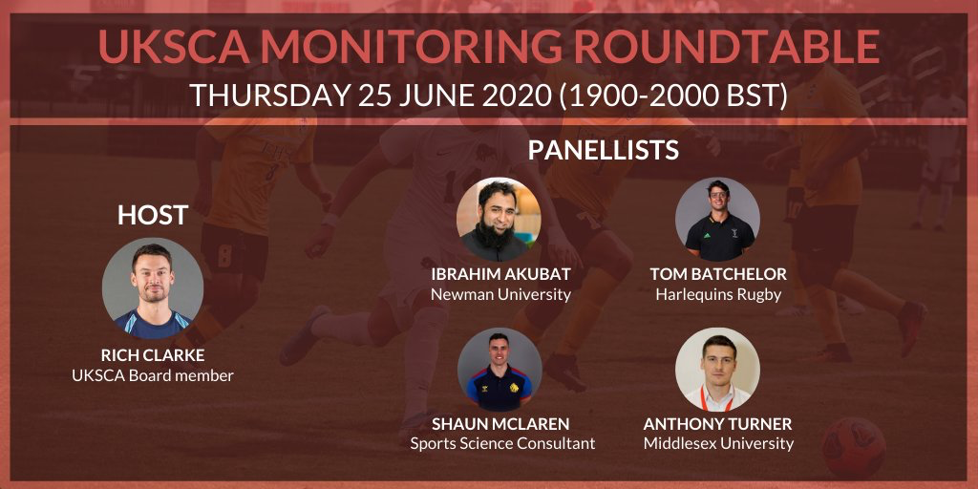

- 7.30pm BST:
GAA: Q&A Series
With Dr Ciaran Kearney
Register here for free: https://learning.gaa.ie/gaacoachwebinar2020

- 11pm BST:
Rugby Canada: Gamification: Chatting with the creator of The Magic Academy
With Russell Earnshaw

Register here for free:https://t.co/hRLPPm2itE?amp=1

