Webinars

Tuesday 2nd June

- 3pm BST:
Liam Anderson: Sport Science Journal Club
Marcus Hannon (Head of Nutrition, Aston Villa FC), Dr Elliot Hall (Post Doc Researcher, Manchester Met Uni), Dr Stacey Emmonds (Senior Lecturer, Leeds Beckett)

Register here for free: https://t.co/tp4nQhngSF?amp=1
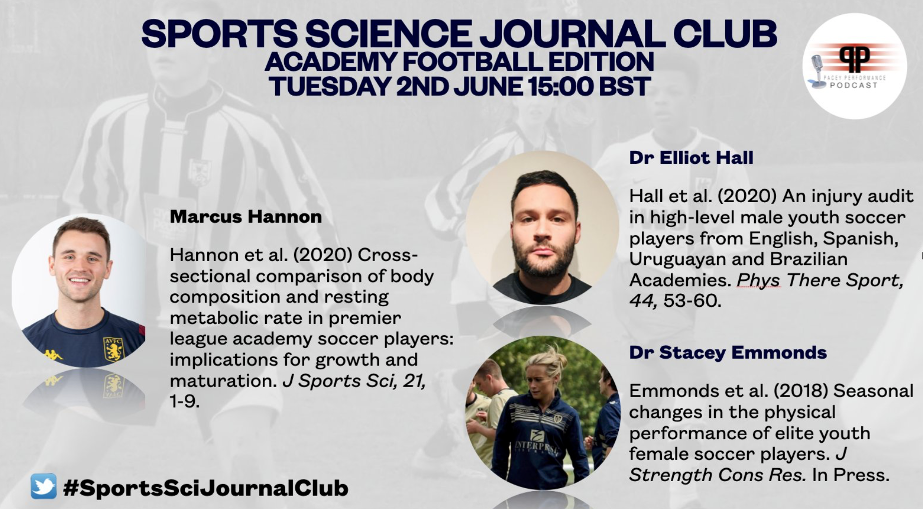

- 5pm BST:
Jay Bhindi - Tactical Periodisation Webinar (First Team Analyst of Austin Bold FC) (USL)

Register here for free: https://event.webinarjam.com/register/87/w6v68b73

- 7pm BST:
England Rugby: Coaching the Breakdown
John Mitchell (Defence Coach, England Rugby)

Register here for free: https://t.co/TSv8UEGjwq?amp=1

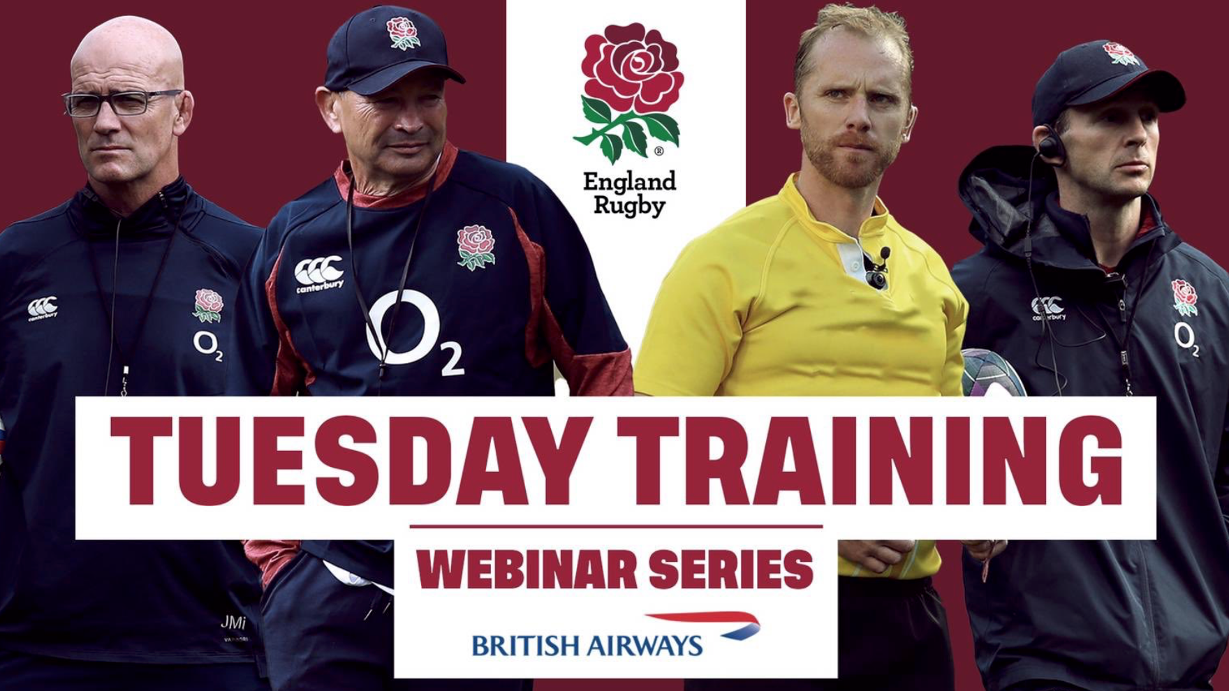

- 7:30pm BST:
GAA: Webinar Q&A with Dr Julia Walsh

Register here for free: https://learning.gaa.ie/gaacoachwebinar2020

Webinars

Wednesday 3rd June
- 11am BST:
Sport Video Analysis: Kef's Coaching Corner with Toutai Kefu (Head Coach, Tongan Men's Team)
Register here for free: https://t.co/PAH6PBsZqb?amp=1

- 3pm BST:
Joe Eisenmann - #LTADChats: The Youth Physical Development Model
Dr Jon Oliver Professor of Applied Paediatric Exercise Science, Youth Physical Development Centre, Cardiff Metropolitan University
Dr Rhodri Lloyd (Reader in Paediatric Strength and Conditioning, Cardiff Metropolitan University

Register here for free: https://zoom.us/j/697756513

- 4pm BST:
John Wall (CEO of GameInsight soccer): Bielsa - Rotations and interchanges
Register here for free: https://event.webinarjam.com/register/88/rk5k4fpo

- 7pm BST:
Rugby Academy Ireland: Coaching Women & Girl (Womens Rugby)

Caoimhe Morris (Women's Co-ordinator, Rugby Academy Ireland), Orlaith Curran (Athletic Performance Coach, IRFU Women's 15s), Fiona Hayes (Head Coach, UL Bohemians Women's Team & Munster u18 Girls Team), Dan van Zyl (Director, Rugby Academy Ireland), Jessica Myles (CCRO North East, Leinster Rugby), Jennie Scanlon (Girls & minis coach, Greystones RFC)

Register here for free: Link TBC

Webinars

Thursday 4th June:
- 1:30am BST:
Apollo v2: The Final Dance: Michael Jordan's Original Performance Team - Basketball S&C
Erik Helland, Chip Schaefer and Wally Blasé (Former Chicago Bulls Performance Coaches)

Register here for free: https://t.co/rbptOl20fm?amp=1

- 7pm BST:
UKSCA: Roundtable discussion on Internship & Volunteering
Joel Brannigan (Head of S&C, Northumbria University), Tim Jarrett (Leeds Beckett), Duncan Ogilive (DoTraining & Performance), John Walsh (University of Stirling), Claire Tracey (Gloucestershire University), Aden Flannigan (Sheffield Hallam University), Nick Manning (University of Warwick).

Register here for free: https://t.co/GaYKF8UJWm?amp=1

- 7:30pm BST:
GAA: Webinar Q&A with Philip Kerr

Register here for free: https://learning.gaa.ie/gaacoachwebinar2020

- 8pm BST:
Athletics NI: Masters Running Physiology
Colin Griffin (Sport Surgery Clinic)

Register here for free: https://athleticsni.org/News/Athletics-NI-News/Athletics-NI-Zoom-In-To-Coach-Development

