Webinars

Monday 15th June

- 7.30pm BST:
Kidare GAA: Movement Development in Children
Register here for free: https://forms.office.com/Pages/ResponsePage.aspx?id=hrxFrNSvpUKfwz6H4bd_zjI3NlW9Wp9Ggw6Wgc-U4ZpUQ05IUTU0UUlSRzJENElESzFKV1JaSVdSTC4u

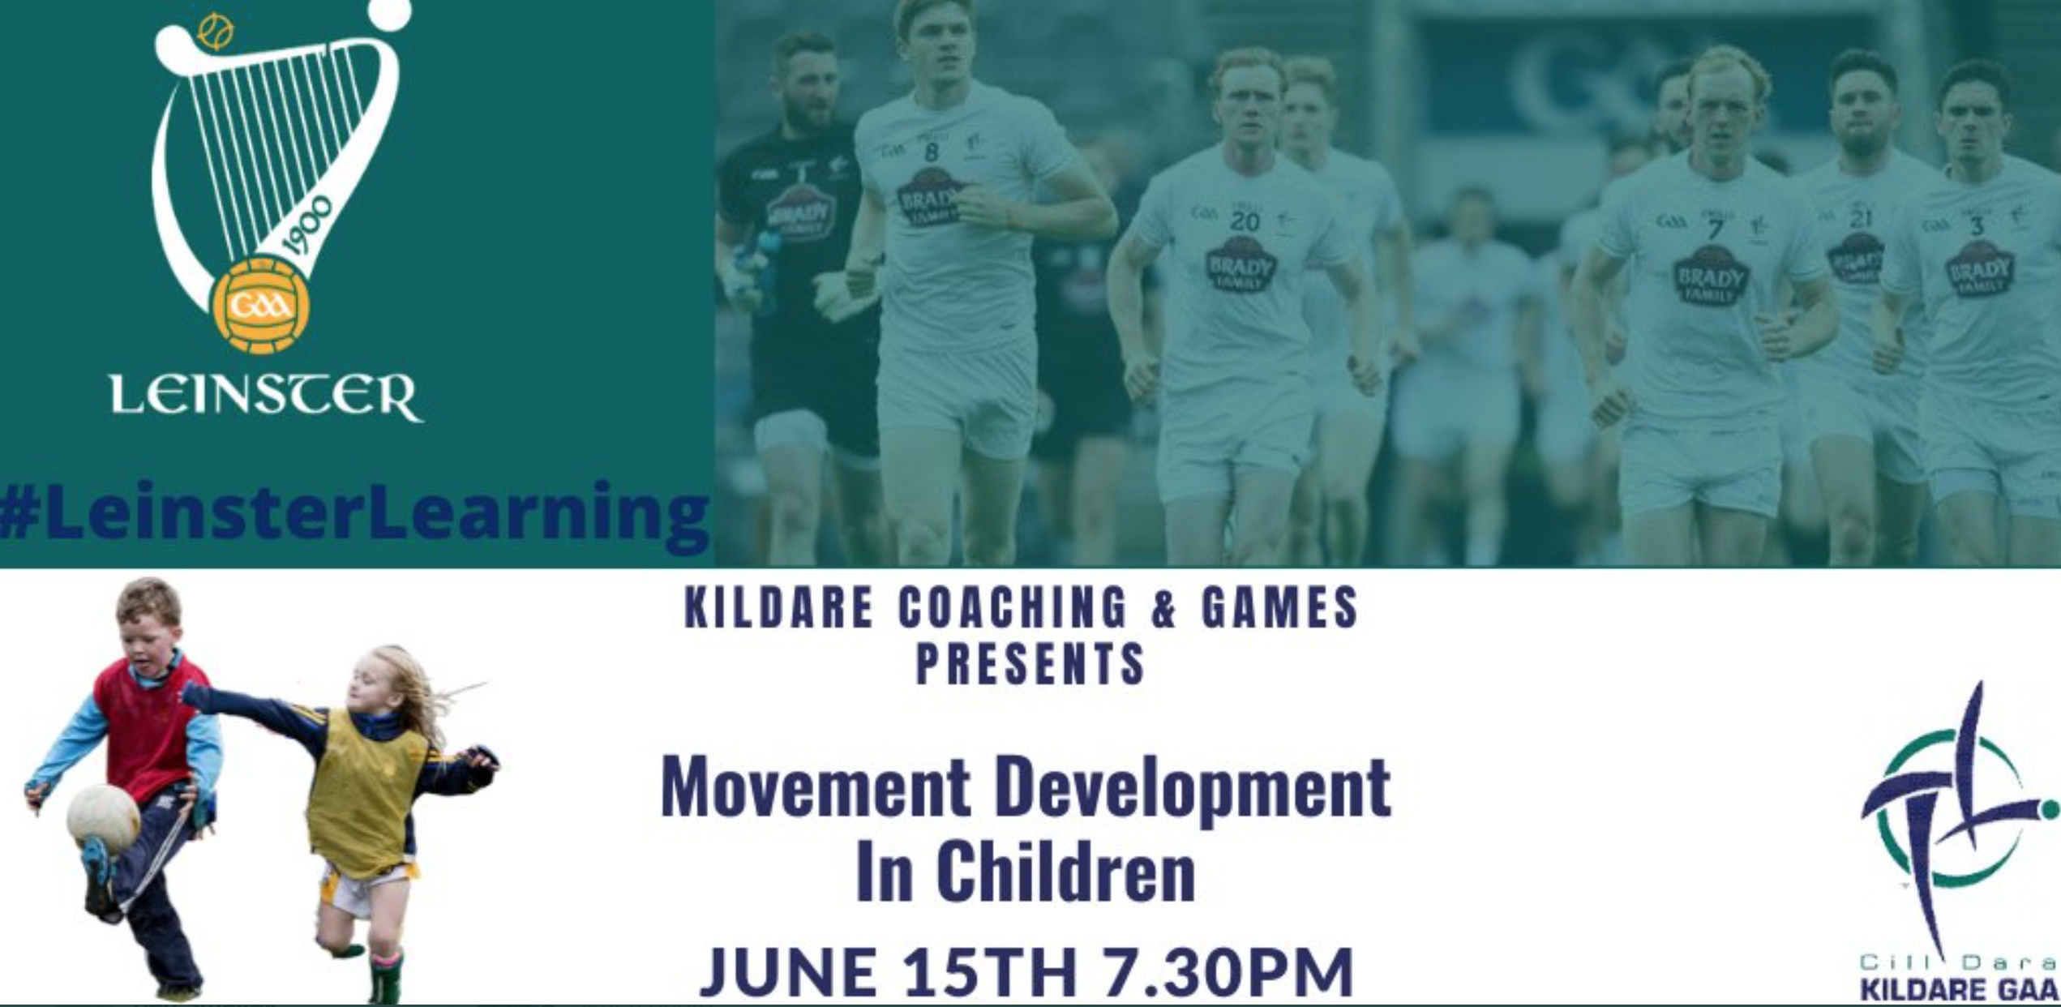

- 8pm BST:
Deely Sport Science: Explanation of Coaching Practices
With Ciaran Deely, Ross Bennett & Joe Coulter
Register here (membership needed): https://elite.deelysportscience.com/dss-subscription-plan/

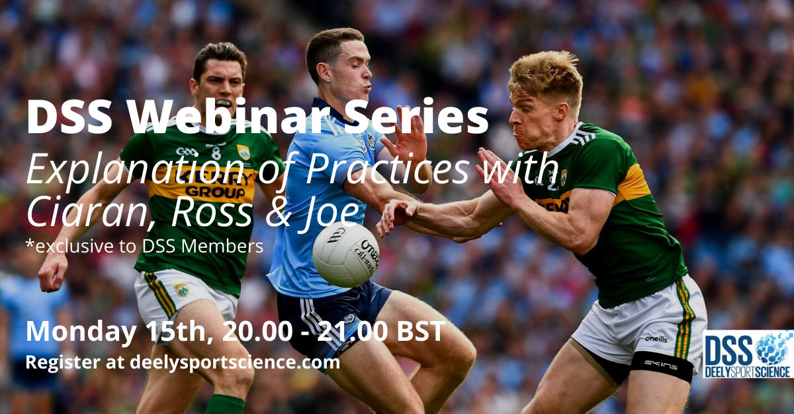

Webinars

Tuesday 16th June
- 11am BST:
Setanta College: Masters Webinar Series Part 1: LTPAD: Setting the Foundations (3 part series)
With Dr Liam Hennessy (President, Setanta College),
Des Ryan (Head of Sport Medicine & Athletic Development, Arsenal Academy),
Shayne Murphy (Lecturer, Setanta College) and
Dr Joe Warne (Lecturer, Setanta College)
Register here for free: https://www.setantacollege.com/masters-webinar-2020-eu/#register
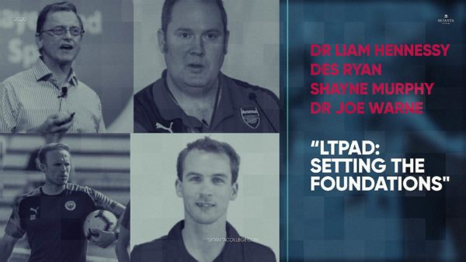

- 6pm BST:
GAA Learning Portal: Covid Return to Play Webinar
With Shay Bannon (Chair of GAA Covid Advisory Group),
Dr Kevin Moran (GAA Covid Advisory Group. Team Doctor, Donegal GAA)
Fergal McGill (GAA Director of Player, Club, and Games Administration)

Register here for free:https://forms.office.com/Pages/ResponsePage.aspx?id=hrxFrNSvpUKfwz6H4bd_zkMBbboVayVBmRHxYVDWS4BUMVZXMFVIMzQxMExKTVVQVjBJRTBVOVlJQi4u

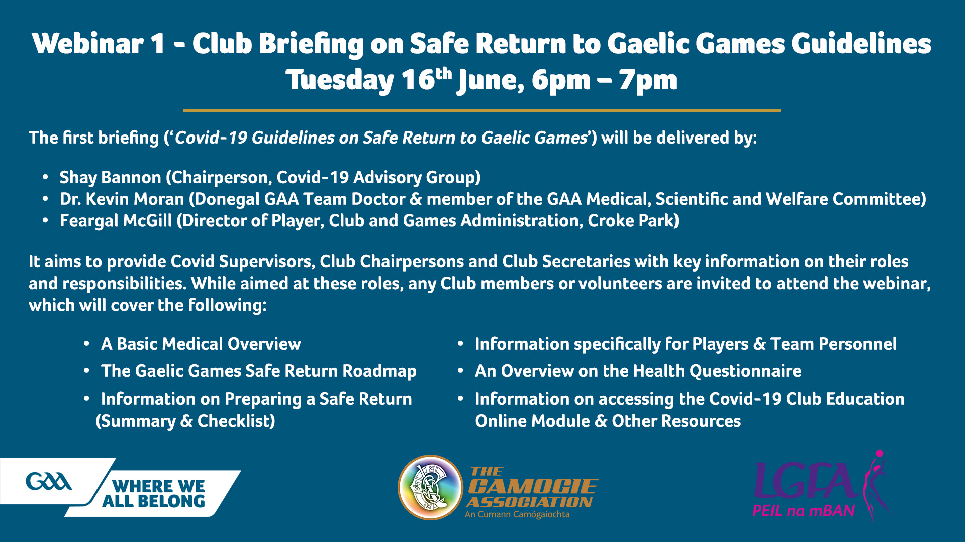

Webinars

Wednesday 17th June
- 11am BST:
Sport Northern Ireland: Creating Amazing Children’s Sport Environments for those who support coaches
With Dr Sergio Lara (Leeds Beckett University and iCoachKidsEu)
Register here for free: https://t.co/UWeTAUwDnN?amp=1

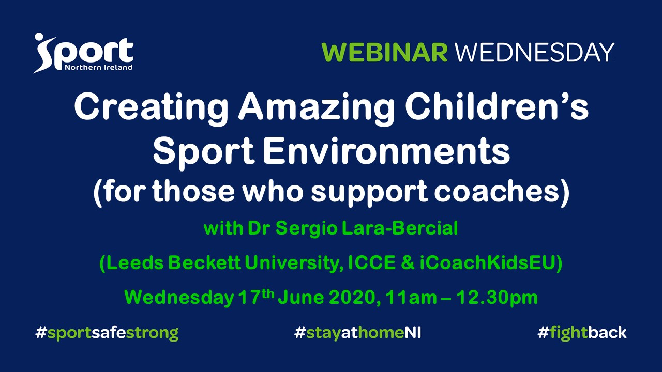

- 6pm BST:
Arete Performance: Team Sport Conditioning Webinar
With Tom Farrow (Founder of Arete Performance & England Men’s 7s S&C)
Register here for £20: https://us02web.zoom.us/webinar/register/8815910997098/WN_WvU8h1yYTvqcVpTSowCXXw
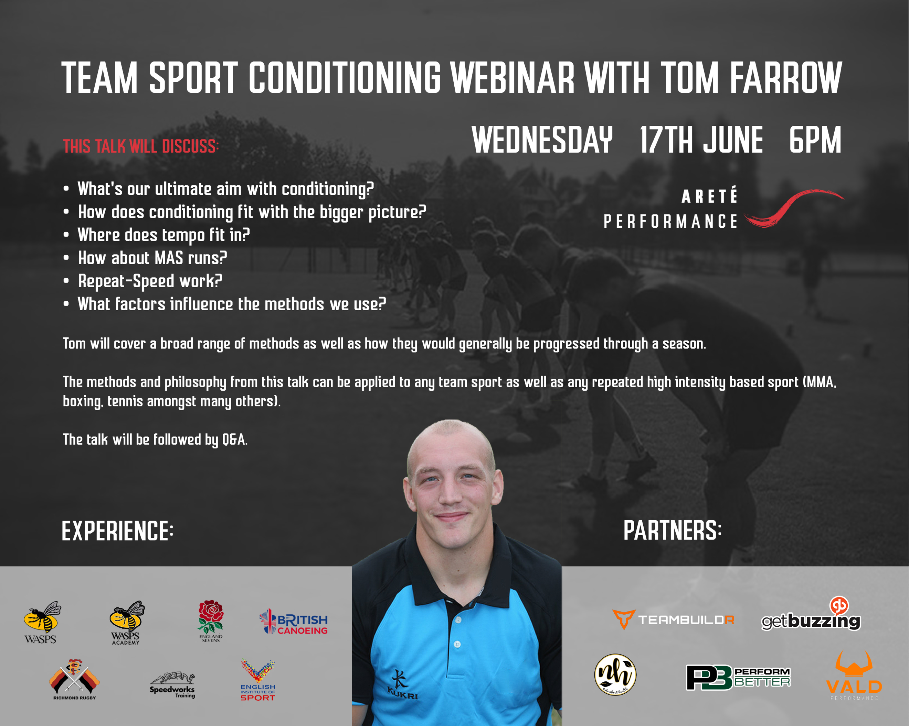

- 8pm BST:
Sport Northern Ireland: Creating Amazing Children’s Sport Environments for coaches
With Dr Sergio Lara (Leeds Beckett University and iCoachKidsEu)
Register here for free: https://t.co/UWeTAUwDnN?amp=1

- 8pm BST:
Dublin GAA: How to be creative in your coaching
With Niall Cooper
Register here for free: https://t.co/loMyIaJRi1?amp=1

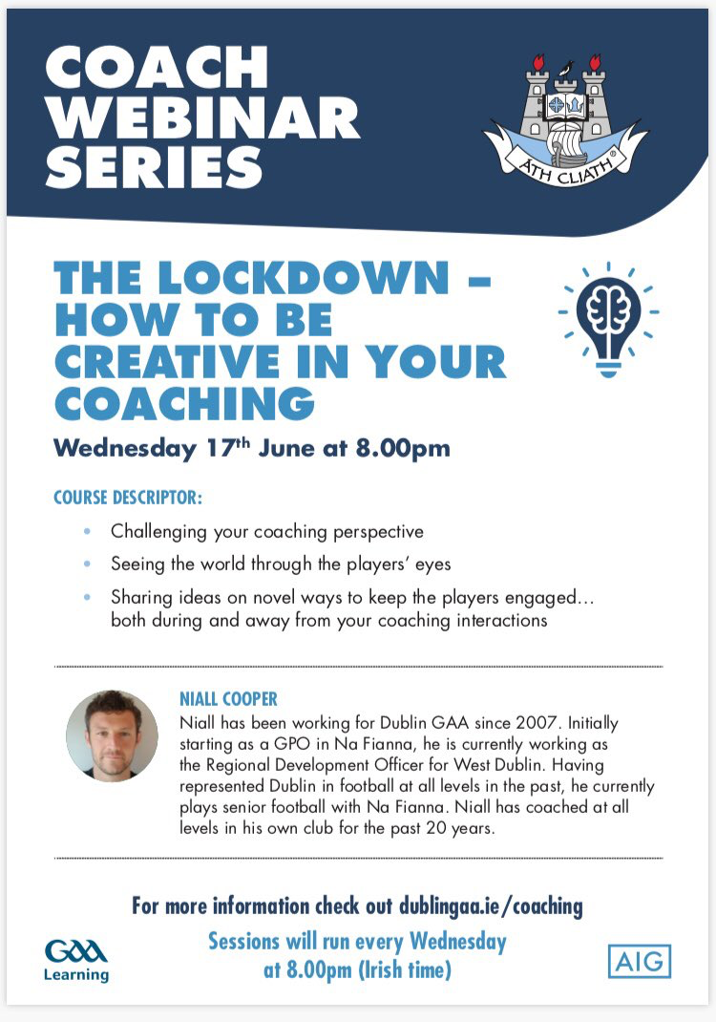

Webinars

Thursday 18th June:

- 1am BST:
LTADchats: Youth Weightlifting
Tony Moreno (Eastern Michigan University), Leo Totten (Totten training), Anna Swisher (USA Weightlifting), Bob Takano (USA Weightlifting), Kevin Simons (Coach, Harrison Marcus).

Register here for free: https://zoom.us/j/697756513

- 11am BST:
Setanta College: Masters Webinar Series P2: The Role of Technology in S&C
Prof Ian Jeffreys (NSCA, UKSCA, Author), Des Ryan (Arsenal FC Academy’s Head of Sport Medicine and Athletic Development), Shayne Murphy (Sentanta College Lecturer), Dr Joe Warne (Sentanta College Lecturer).

Register here for free: https://www.setantacollege.com/masters-webinar-2020-india/

- 6:15pm BST:
Whistle2Whistle: Tackle Jackal Masterclass
Omar Mouneimne (Defence Coach, Worchester Warriors)

Register here for free: https://my.demio.com/ref/mSwUyNXIlndsNHuR?mc_cid=71c46da1d9&mc_eid=0fec52f479

- 7pm BST:
UKSCA: Weightlifting for Sports Performance
Rich Clarke (UKSCA), Shyam Chavda (Middlesex University), Paul Comfort (University of Salford), Shaun Joffe (St Mary’s University), Tim Suchomel (Carrol University), Anna Swisher (USA Weightlifting).

Register here for free: https://t.co/CnGjqJUhTA?amp=1

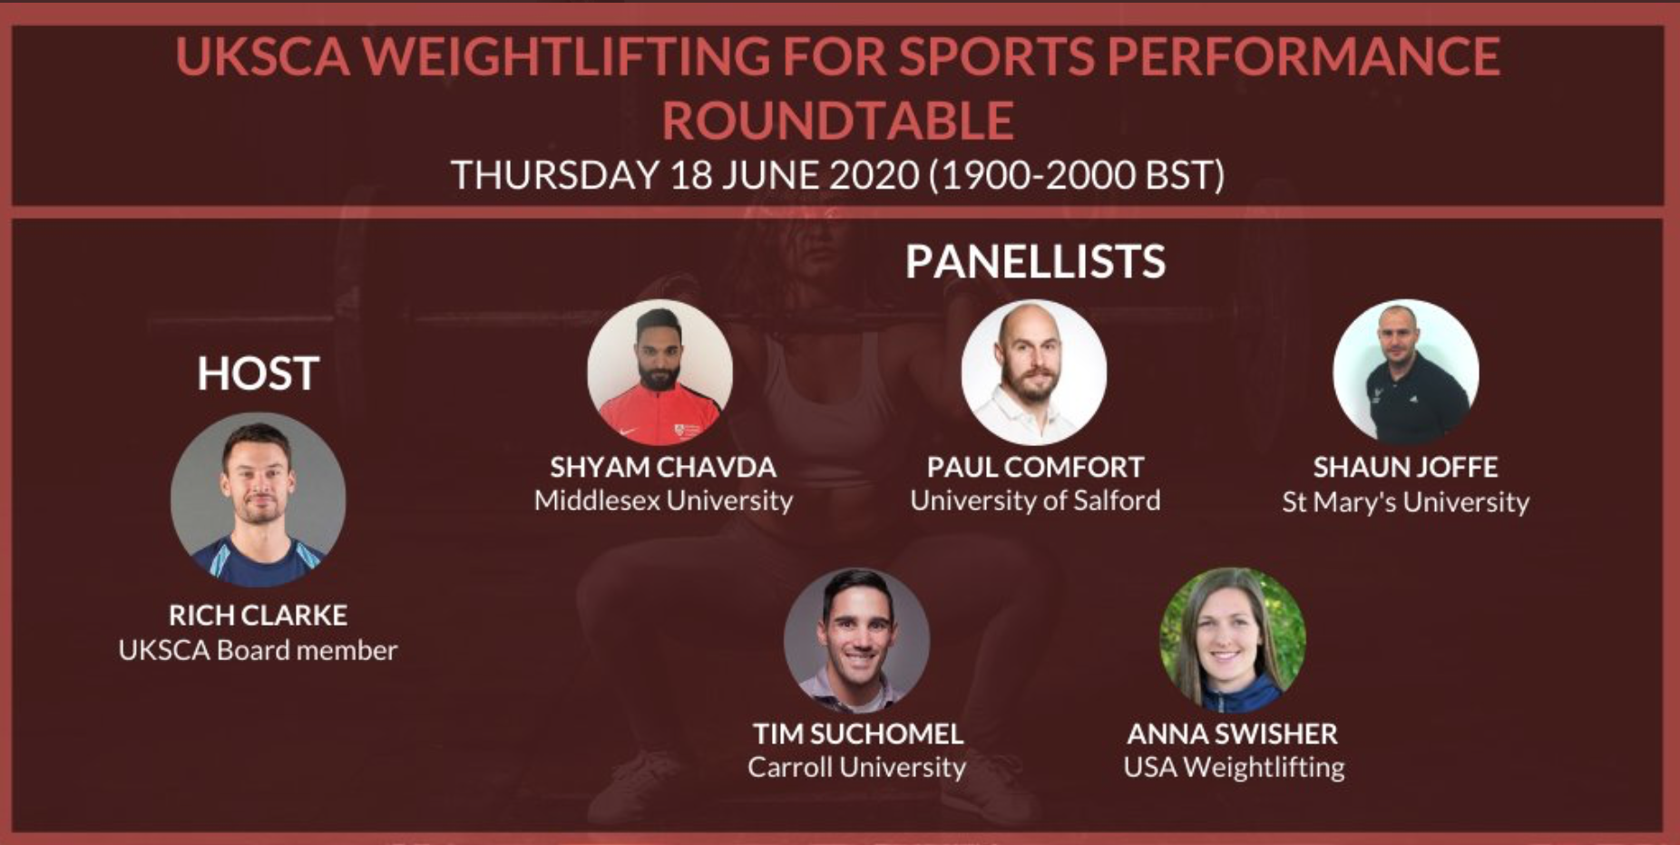
- 8pm BST:
Athletics Northern Ireland: Moving up the distances
Andy Hobdell and Rob Hawkins

Register here for free: https://athleticsni.org/News/Athletics-NI-News/Athletics-NI-Zoom-In-To-Coach-Development

Webinars

Friday 19th June:

- 7pm BST:
Kildare GAA: Maximising Training Adaptations with Paul Divilly & Michael Gillick

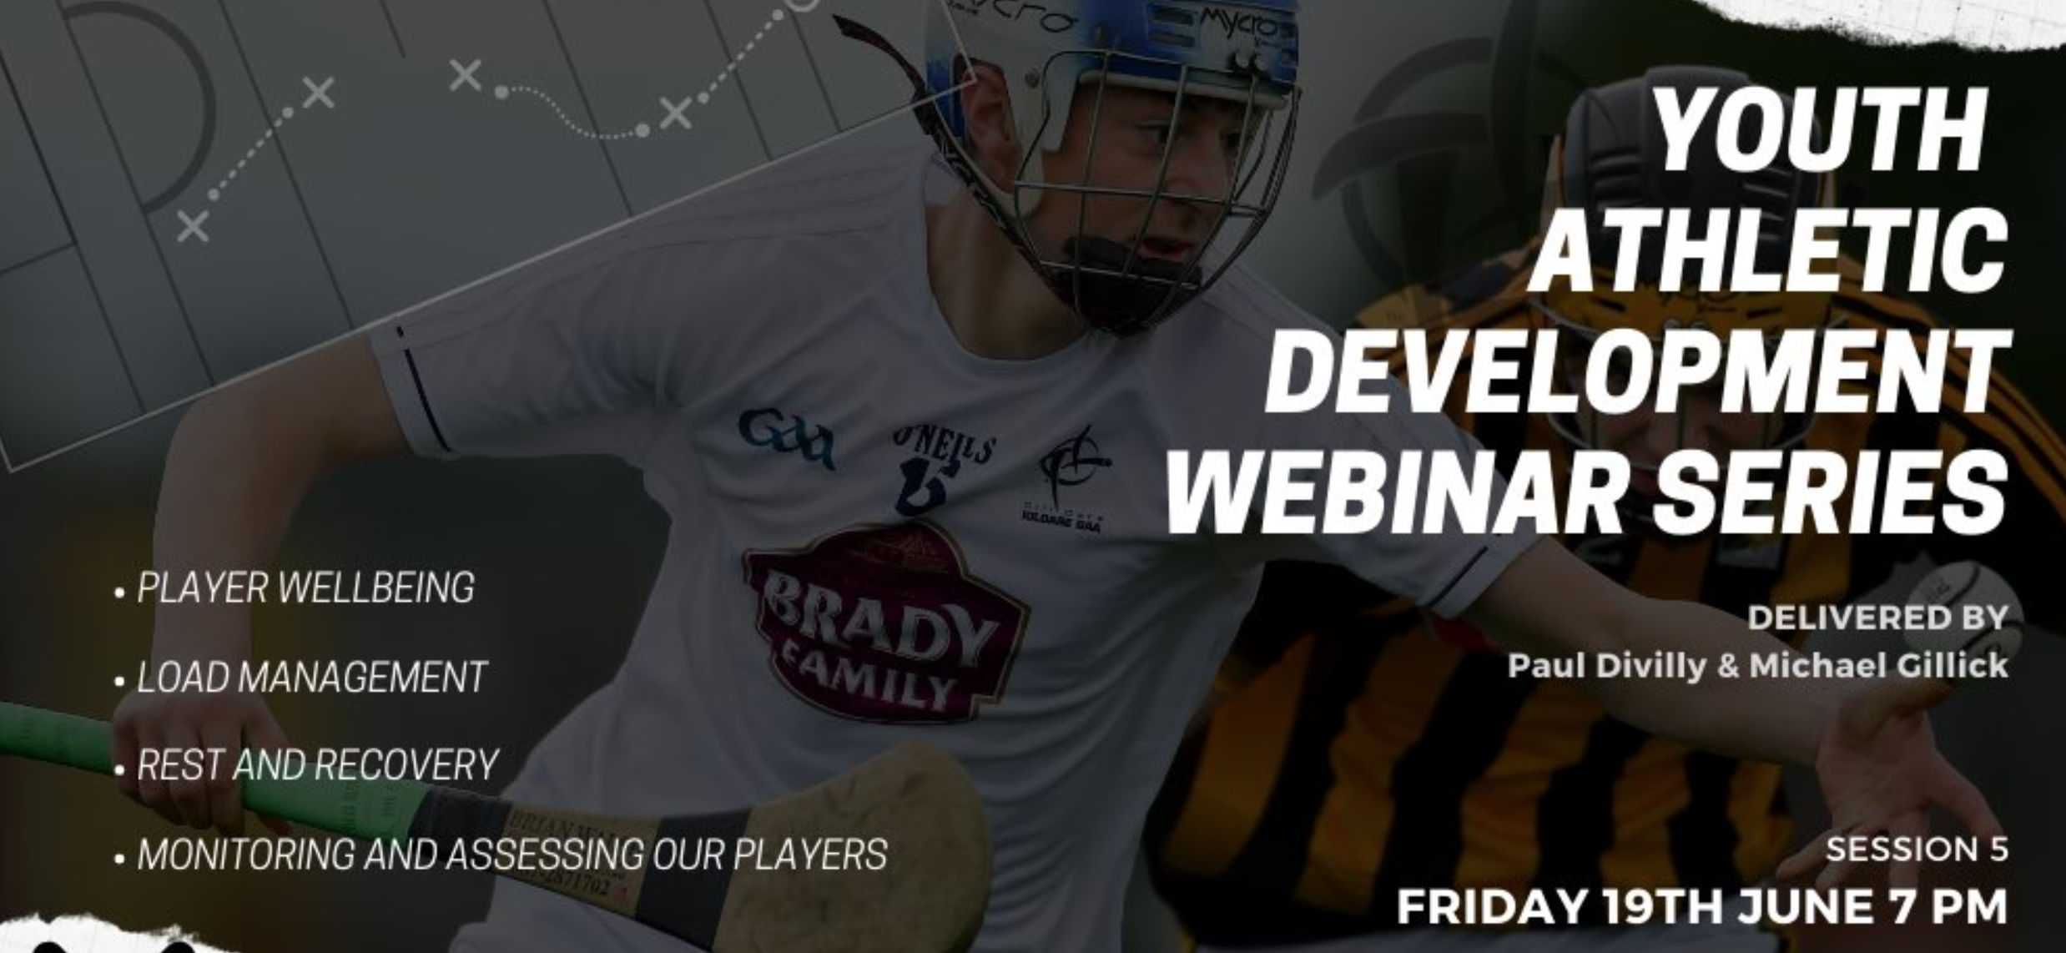
Register here for free: https://t.co/3WquiulYhD?amp=1

