Webinars

Monday 4th May
- 11am BST:
Arsenal Performance and Research Team: Defining mental health and wellbeing: What it is and isn’t
Andreas Ivarsson

Register here: https://t.co/IuN520DFhG?amp=1

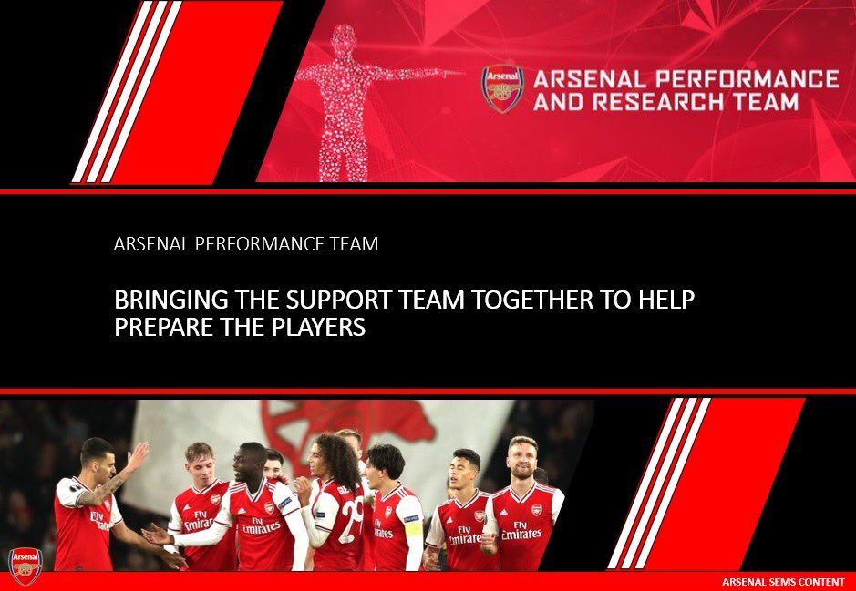

- 1pm:
ACSM Combat Sport Conference Day 1: Combat Sport Online Conference

Dr Ian Durcan (Adjunct Associate Professor (ECU), Senior Research Fellow (UWA))
The effects of water loading and rapid weight loss on sleep quality and quantity in combat sport athletes

Bruno Follmer (PhD Student in Kinesiology, Rehabilitation Neuroscience Lab, University of Victoria, Canada.
Understanding the vicious cycle of concussion knowledge in combat sports

Dean Amasinger (Director of MMA/Head Coach at UFCPI Shanghai)
Applying periodization in a team setting at a professional MMA training facility: How to meet individual’s needs, in the team environment

Dr Carl Langan-Evans (Researcher in combat sports)
The Lowdown on the Rebound: Assessing Energy Availability & Within Daily Energy Balance to Make Weight Safely in Combat Sports

David Nolan (Coach & Educator (Synapse). Head of Performance at Rugby Academy Ireland.)
Prevalence, magnitude & methods of rapid weight loss in male and female powerlifters

Pedro Perim
Buffer supplements: mechanics of action, recommendation and use on combat sport

John Connor (Strength Coach, Irish Strength Institute)
Comparison of hot water immersion at 37.8°C with or without salt for rapid weight loss in mixed martial arts athletes

Register here:
docs.google.com/forms/d/e/1FAIpQLSdBShkWemRF1-F2UlNYnavxFvYmX2yeMJu7bQzk6ATitu0jnQ/viewform?usp=sf_link

- 7pm:
New York GAA: Women in sport

Eimear Considine
Irish Rugby International (15s)

Ailish Considine
Adelaide Crows AFL Player

Register here: https://forms.office.com/Pages/ResponsePage.aspx?id=hrxFrNSvpUKfwz6H4bd_zlA9l_WCHpBIoUSzcJq31yZUOUlIRkgyTU9KUlQzMFROVEFUUjBaS1JYVC4u

Webinars

Tuesday 5th May:

- 3am:
British Columbia Rugby: Women in rugby
Jenn Joyce

Register here: https://us02web.zoom.us/meeting/register/tZUlc-GorD0qH9EqfZCoF1pLdPmPyYcv4fwq?timezone_id=Europe%2FDublin

- 10am:
Arsenal Performance & Research Team: Maximising Sleep and Recovery
Shona Halson - Associate Professor, School of Behavioural and Health Sciences, ACU
Register here - https://t.co/IuN520DFhG?amp=1

- 2pm:
STATSport: Approaches to Monitoring in Football: Match Day -2

Dr Matt Taberner (Post Doctorate Researcher, LJMU) - Consider the chaos: ecological validity in the Return to Sport process

Dylan Mernagh (QPR) - Developing “R” Way

Hani Al Haddad (Qatar FA) - Monitoring players physical activity in football: considerations and applications

Register here - https://statsports.com/webinar-series/session-5/

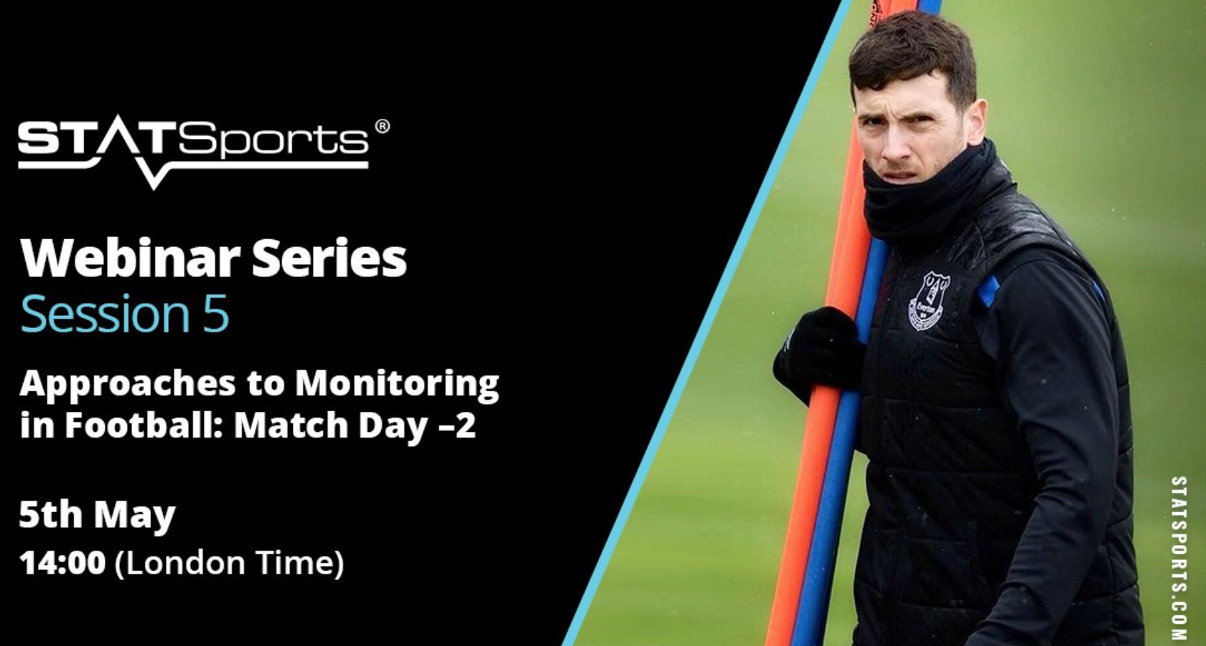

- 7pm:

England Rugby: Principles of Defence p1
Stuart Lancaster

Register here - https://t.co/8qpvzR2PyL?amp=1

- 7pm
Athletics Ireland: Pelvic Floor Training with Lorraine Boyce
Register here - https://eventmaster.ie/event/61ltEpT5G

- 7:30pm
GAA Learning Portal: Game Centred Approaches to Sport
Dr Shane Pill (Associate Professor, Flinders University)

Register here - https://learning.gaa.ie/gaacoachwebinar2020

Webinars

Wednesday 6th May
- 8.40am – 7.40pm:
Rehab in sport for the S&C Coach with Aidan Oakley

Dr Ebonie Rio - Tendon Q+A
Jason Webber - Hamstring
Thihan Chanramohan - Shoulder
Cam Dyer - Groin
Simon Harries - Calf
Mike Rennie - Quad
Jonny King (Bournemouth) - ACL
David Breen (Wasps) - Syndemosis
Adam Mattlussl (The Royal Ballet) - Ankle
Jonny King (Bournemouth) - ACLR - When can I run?
Sam Blanchard - Hamstring
Pete Burridge (Leicester Tigers) - GPS led RTP
Nick Court (Bournemouth FC) - Hamstring
Fearghal Kerin - Groin
Edel Fanning (Sport Surgery Clinic) - Shoulder
Bill Knowles (Knowles Athletic) - Meniscus
Terrence Kennel - ACL
Jonny Alcaraz - Hamstring
Darren Roberts

Register - us02web.zoom.us/webinar/regist…

- 10am
Arsenal Performance & Research Team: Swimming at the 2020 Tokyo Olympics - where to next

Steve Tigg - Head Performance Swimming Coach; University of Stirling
Jon Twynham - Physiotherapist

Register here - https://t.co/IuN520DFhG?amp=1

- 1pm
Athletics Ireland: Athlete Mobility
Ciara McCallion (Irish International Squad Physiotherapist)

Register here - https://eventmaster.ie/event/2Ajf2qc0z

- 6:30pm
Sport Surgery Clinic: Online Educational Evening focusing on Orthopaedics & Sports Medicine

Prof Cathal Moran, Consultant Orthopaedic Surgeon - Sporting knee and shoulder injuries.

Ms Katie Gill, Senior Physiotherapist - Low Back pain: assessment and management’

Ms Ann Maria Byrne, Consultant Orthopaedic Surgeon - Tendinopathy about the elbow’

Register here - https://t.co/YqPcF5hKXx?amp=1

Webinars

Thursday 7th May
- 10am:
Arsenal Performance & Research Team: Measuring wellbeing in athletes - is it possible

Annie Jeffries - PhD candidate, University Technology Sydney
Franco Impellizzeri - Professor in Sport and Exercise Science and Medicine at UTS

Register here - https://t.co/IuN520DFhG?amp=1

- 7pm:
Athletics Ireland Club: Development & Planning
David Denieffe

Register here - https://eventmaster.ie/event/ELJu4EF74

Webinars

Friday 8th May

- 10am:
St Mary's Twickenham: Performance Analysis & Talent ID

Performance Analysis -
Stuart Key (PA Bears Cricket Club) - Performance Analysis in County Cricket'
Stewart England (Performance Analyst (Brisbane Roar)) - Opposition Analysis: The How, Why and What'
Chris Loxton (Performance & Game Analyst (FIFA)) - The Other Side of Performance Analysis'

Talent ID -
Brett Igoe (MSc Sports Performance Analysis Lecturer (IT Carlow)
Leinster Schools Defence Coach (Leinster Rugby) - Developing Strategy using Performance Analysis'
Dan Petts (Assistant Coach U20 Men (GB Basketball)
Scouting and Player Development (Obradoiro CAB)) - Making Data Driven Decisions'
Hugo Chandler (Performance Analyst (Southern Vipers)) - Building a Profile as a Performance Analyst in Cricket

Register here - https://t.co/lsF6mZW3Qc?amp=1

- Time TBC
Arsenal Performance & Research Team - Surprise guest

Register here - https://t.co/IuN520DFhG?amp=1

Webinars

Saturday 9th May

- 1pm:
ACSM Combat Sport Conference Day 2 - Combat Sport Online Conference

- 3pm:
#LTAD Chats
Rick Howard
Joe Eisenmann
Tony Moreno

- 5pm:
Movement & Skill Acquisition Ireland: Knowledge & Toolkit to Aid the Prevention of Youth Sport Dropout

Prof Catherine Woods (Professor, Physical Activity for Health, Department of Physical Education and Sport Sciences, University of Limerick)

Dr Joey Murphy (Post Doc Researcher, Irish Physical Activity Research Collaboration)

Register here - https://twitter.com/MSAIreland

