Webinars

Monday 25th May
- 3pm BST:
Sudamerica Coaching: Leaders in Sport Series
With Sarah Kelleher (England Hockey U18 Coach) via Zoom.
Email them for free access (info@sudamericacoaching.com)

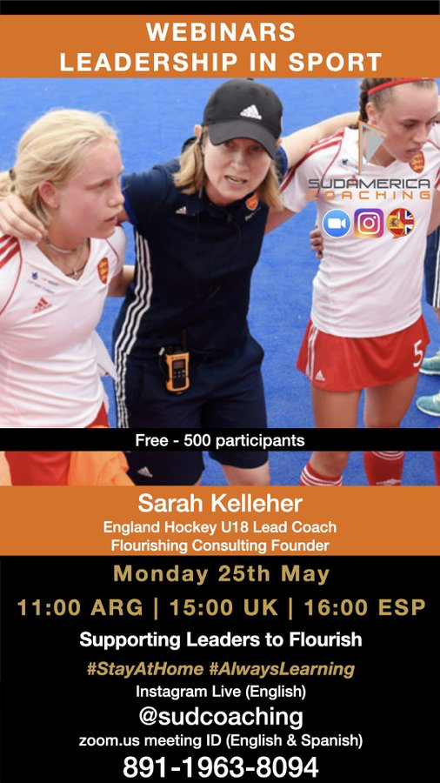

- 7pm BST:
New York GAA: Injury Prevention in Gaelic Games
With Ciara O’Malley.
Register here for free: https://t.co/GVhIM3cBph?amp=1
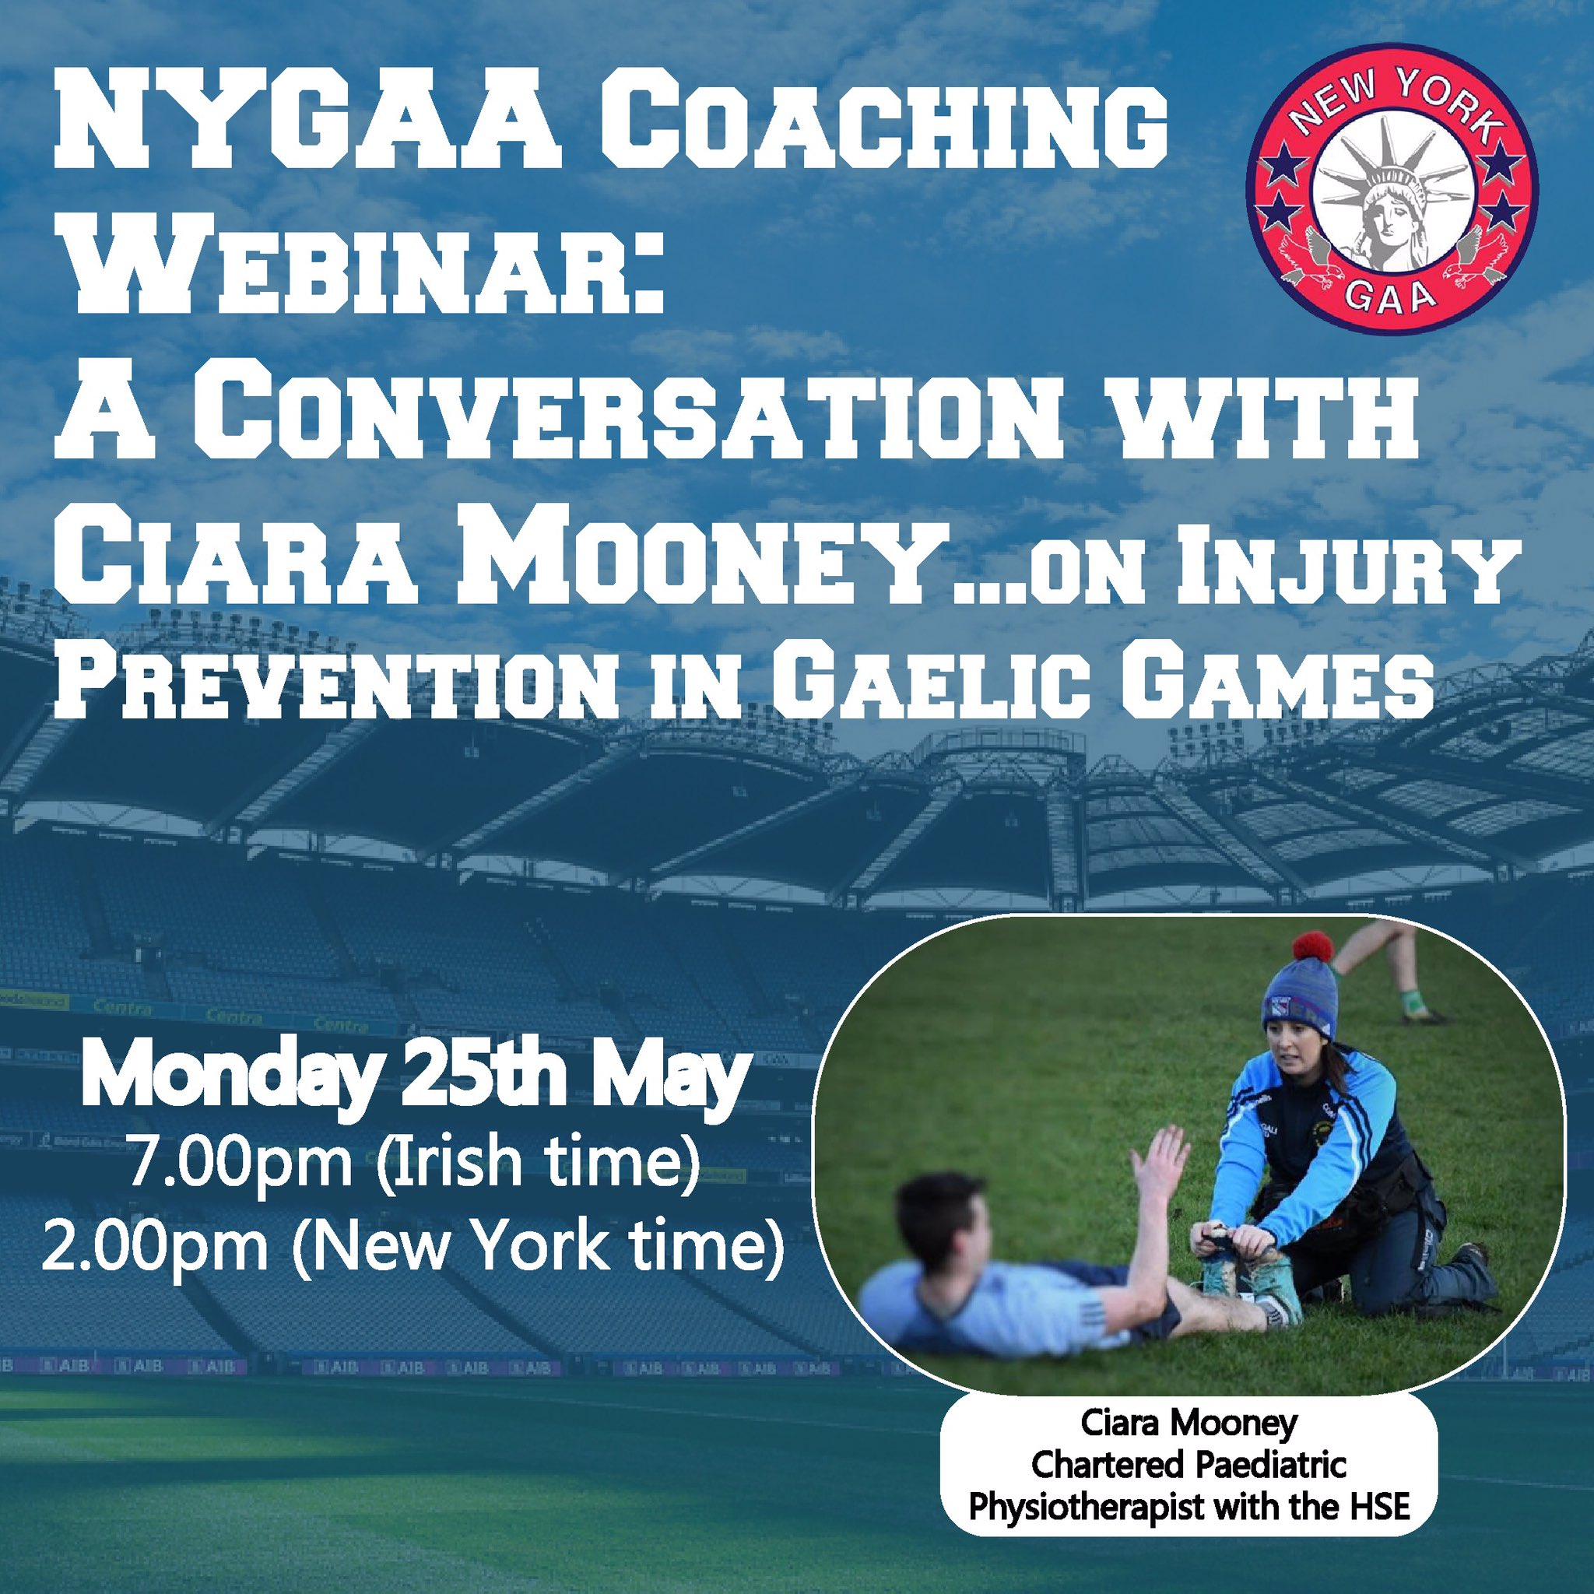

- 7.30pm BST:
Kildare GAA: Building resilience in your players
With John Doyle & Dave O’Neill of Kildare GAA
Register here for free: https://forms.office.com/Pages/ResponsePage.aspx?id=hrxFrNSvpUKfwz6H4bd_zjI3NlW9Wp9Ggw6Wgc-U4ZpUQ05IUTU0UUlSRzJENElESzFKV1JaSVdSTC4u

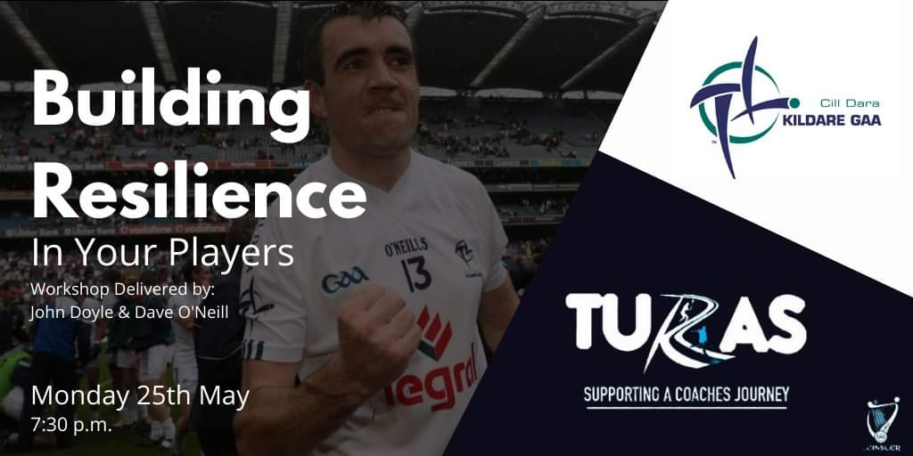

- 7.30pm BST:
Hockey Ireland: Effective S&C for Club Players
With Darren Kenna (Hockey Ireland S&C)
Register here for free: https://t.co/BqVsr7TbFH?amp=1

- 12am BST:
OnBaseU: Live Q&A Series
With Eric Cressey (Director of Player Health and Performance, New York Yankees)
Register here for free: https://t.co/BsRQ2LXaor?amp=1

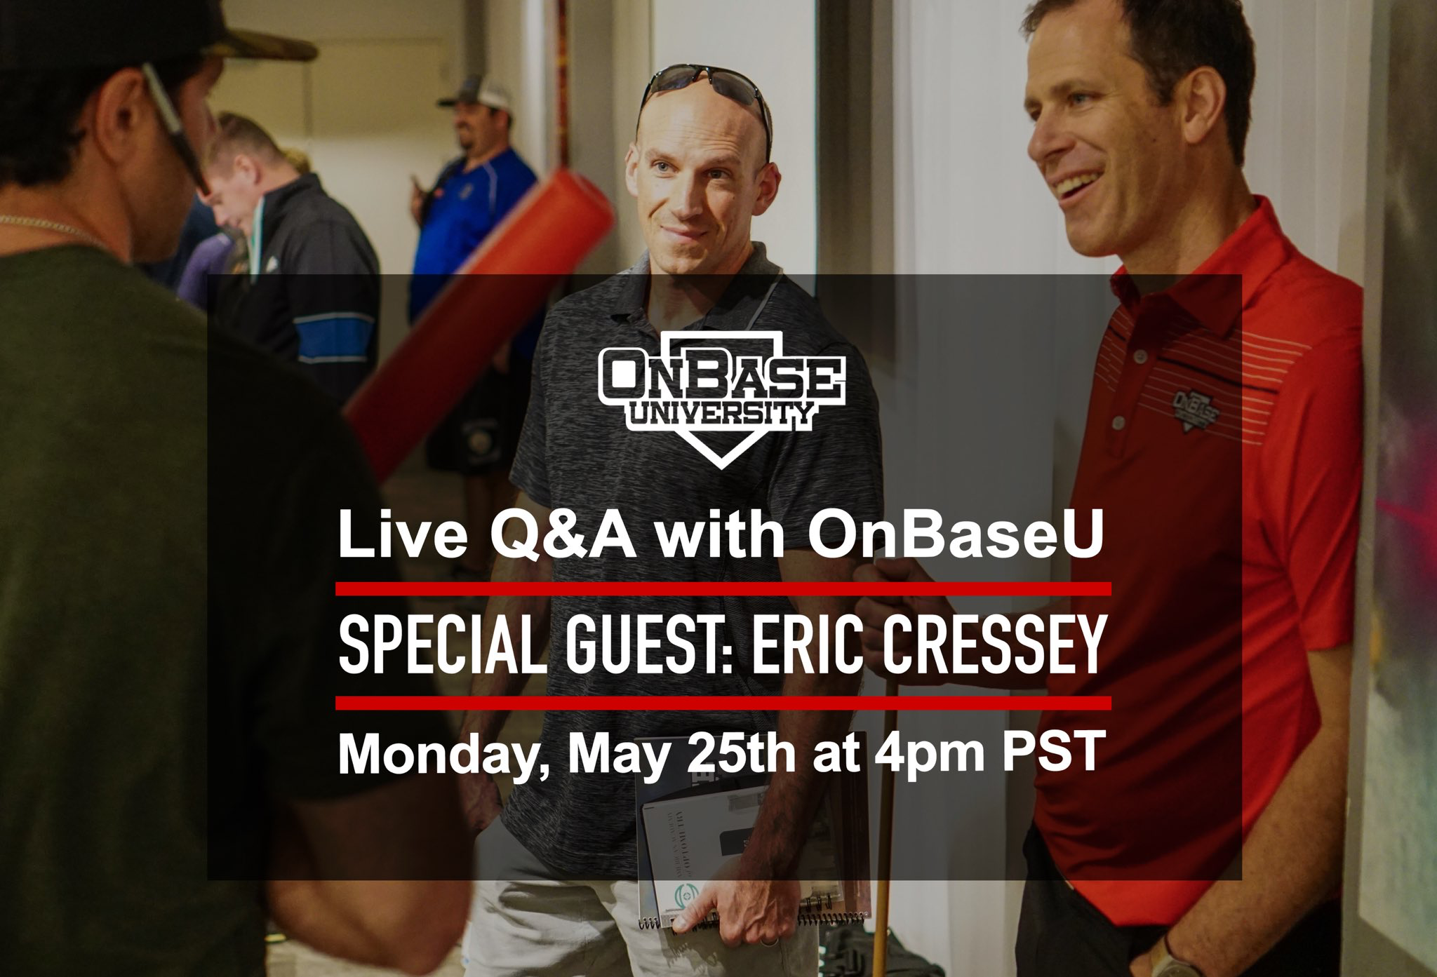

Webinars

Tuesday 26th May
- 7pm BST:
England Rugby: Use it or Lose it! Embedding learning into your regular coaching/refereeing practice
With Richard Cheetman (Lead coach education, research and development. Senior Fellow at University of Winchester)
Register here for free: https://t.co/5wx6IWp1rh?amp=1

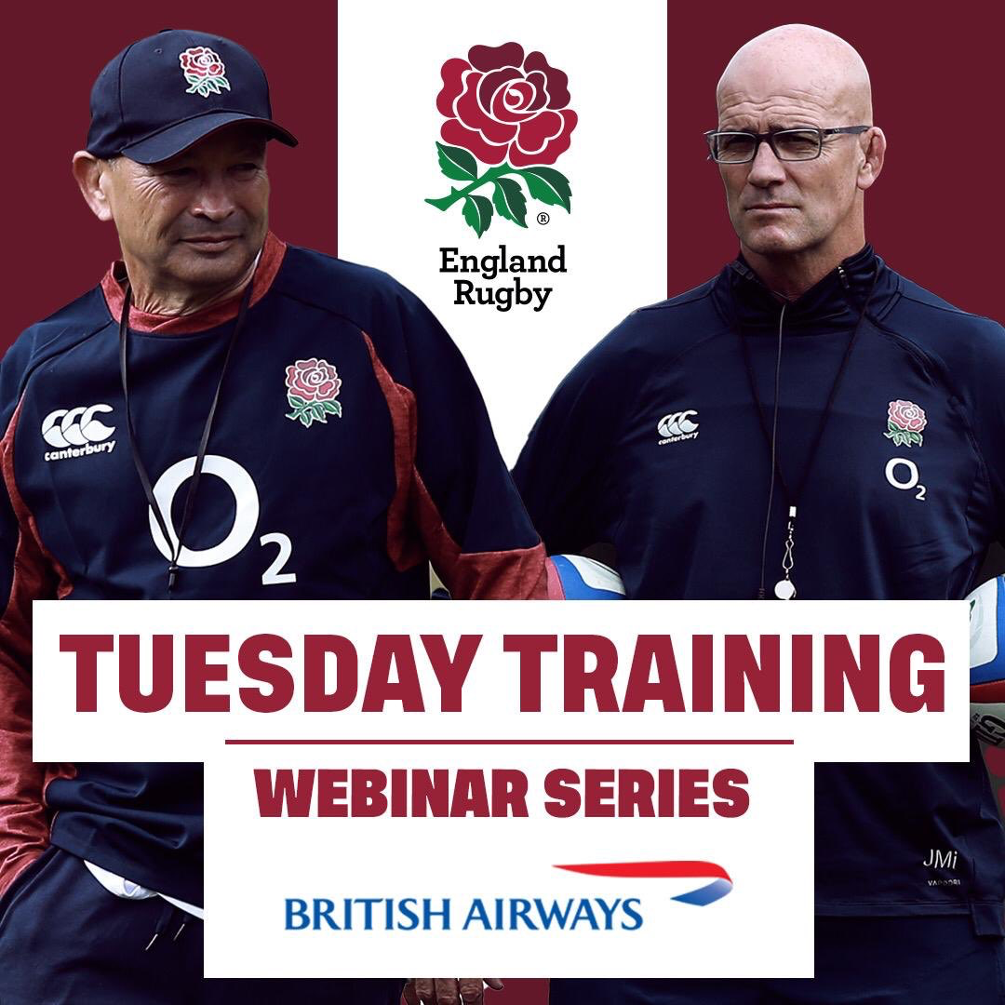

- 7.30pm BST:
GAA: Returning to Gaelic games post COVID - Keeping your squad fit and preventing injury
With Eamonn O’Reilly of SPARC
Register here for free: https://t.co/RmQJoDvLMW?amp=1

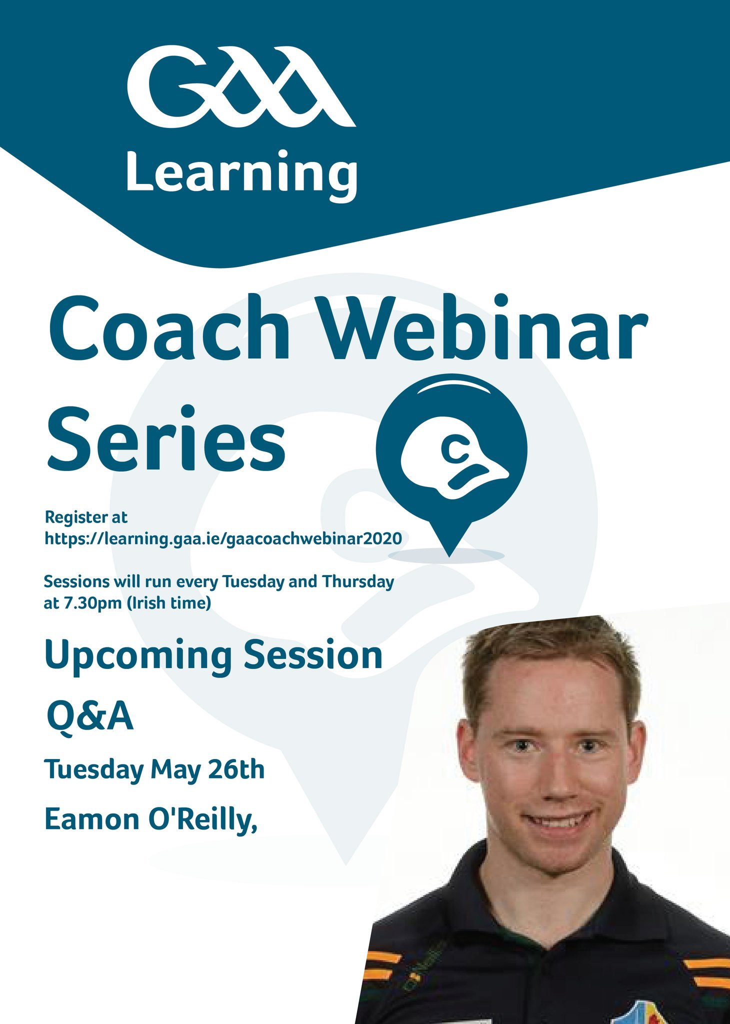

Webinars

Wednesday 27th May:
- 12pm BST:
Jonas Dodoo: Deceleration in Sport
With Damian Harper (BASES & UKSCA)
Register here for £25: https://speedworks.training/product/coaching-eye-webinar-with-binary-app-included-part-2-deceleration-with-damian-harper-and-jonas-dodoo-and-binary-app-voucher-code/

- 8pm BST:
Human Kinetics: Over-training and Sport Performance
With Dr Andy Fry
Register here for free: https://t.co/vg1HkRCzbF?amp=1

Webinars

Thursday 28th May
- 12pm BST:
IRFU Analytica 202 - Sports Analytics Conference Day 2 Performance Analytics

Andy Farrell (Ireland Men's Head Coach), Paul Brand (Man United), Prof David Sumpter, Colin Byrne (Pro Caddy), Rhodri Bown Welsh (Rugby Union), Meaghan Chaykas (CEO, Stathletes), Amber Luzar (GB Hockey), Mike Hughes (Insight Analysis), Kate Burke (RFU), Murray Kinsella (Journalist, The42.ie), Tom Savage (Three Red Kings), Jonny Cooper (Dublin GAAc), Johnny Sexton (Ireland Captain)

Register here for €30: https://www.eventbrite.ie/e/analytica-2020-tickets-105451343808?utm-medium=discovery&utm-campaign=social&utm-content=attendeeshare&utm-source=strongmail&utm-term=listing

- 3.45pm BST:
The Women’s Dance
Rachel Balkovec (Houston Astros, NY Yankees), Sue Falsone (EXOS, LA Dodgers),
Dawn Scott (England WNT and USWNT)

Register here for free: https://zoom.us/webinar/register/9515901516960/WN_BTf6fD-xQVazwF8wS25URw

- 5pm BST:
The Leinster way
Roundtable insight into an elite rugby S&C system
Cillian Reardon, Joe McGinley, Robin Reidy

Register here for free: https://zoom.us/webinar/register/WN_MpYpvLonTzyIdTA2myvmsA

- 6pm BST:
STATSport: Webinar series session 8
Monitoring on the grid iron: A round table discussion
Cecil Martin (NFL analyst), Chris Laskowski (UNCC), Adam Lachance (Miami Dolphins), Grant Geib (WMU), Marc Lewis (Virginia Tech)

Register here for free: https://statsports.com/webinar-series/session-8/

- 7pm BST:
UKSCA: Female training roundtable
Dawn Scott (Physical Performance Manager), FA Stacey (Emmonds Leeds Beckett), Guy Pitchers (Charlton Womens FC), Jack Clover (Everton Womens), Tracey Neville (Former head coach, England Netball), Alex Buchman (University of South Carolina), Ivi Casagrande (Orlando Pride)

Register here for free: https://t.co/0aZdkdv5zd?amp=1

- 7.30pm BST:
GAA - Q&A Series
Dr Aine Macnamara (DCU)
James Devane

Register here for free: https://learning.gaa.ie/gaacoachwebinar2020

Webinars

Friday 29th May

- 5pm BST:
MSA Ireland: Coaching Children: The Paradigm Shift
Sheelagh Quinn & Declan O'Leary (iCoachKids & Sport Coaching Ireland)
Register here for free: https://twitter.com/MSAIreland

- 7pm BST:
Kildare GAA: Youth Athletic Development Webinar Series Speed Development
Paul Divilly (Kildare GAA S&C)

Register here for free:
https://docs.google.com/forms/d/e/1FAIpQLSeNDHDrERkdXmj7dVfZgtmX7NWQmJa-eSAF1QuTYg9jnWOxFA/viewform

Webinars

Saturday 30th May
- All day:
Proformance: Child to Champion - Youth Coaching
Dr Dan Baker (President ASCA), Luke Jenkinson (Head of Sport & Academy
Medicine, Derby FC), Simon Brearley (S&C, PGA Tour) Dr Mike Young
(Director of Performance Athletic Lab), Ed Archer (Director Athlete Academy),
Prof Kevin Till (Carnegie School of Sport, Leeds Beckett), Nicole Rodriguez
(Physical Development Lead, BVB Akademia Im.Lukasza).

Register here:
https://proformance.pro/product/child-to-champion-uk-online-event-3031-may/

