Webinars

Monday 18th May
- 8am BST:
Coach Logic: Coaches Coaching Coaches
With Edward Coughlan (Skill Acquisition Expert) via Zoom.
Register here for free (https://t.co/o5Qbnw177d?amp=1)
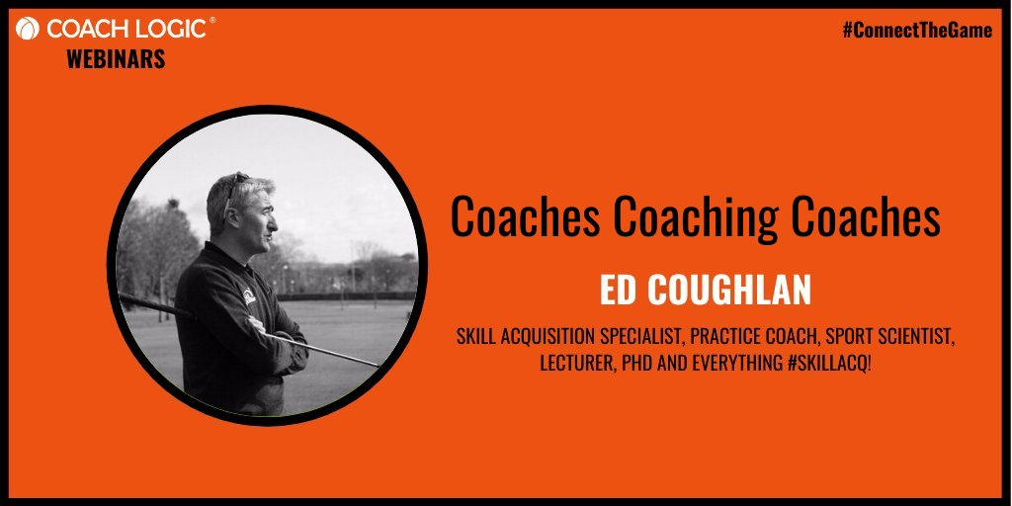

- 5pm BST:
US Soccer: #SheBelieves Virtual Network: Build your Confidence
Hosted by Joan Kuhl (Author of “Dig Your Heels In”).
(https://attendee.gotowebinar.com/register/7953736680332263440)
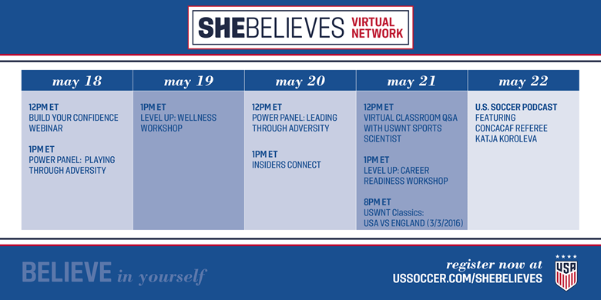

- 6pm BST:
US Soccer: #SheBelieves Virtual Network - Playing through Adversity: The Athlete Perspective.
Hosted by Jenny Taft (Fox Sports) with Crystal Dunn (US Soccer Women’s National Team Player), Lynn Williams (WNT Player), Melissa Stockwell and Abbey Weitzeil (Former WNT Player)
Register here for free: (https://register.gotowebinar.com/register/1802834438576713488)

- 7pm BST:
Advanced Sprinting Webinar
Hosted by Kebba Tolbert (Harvard University Women’s Sprint Coach)
Register here for $59: (http://tiny.cc/AdvancedSprintsKT…)

- 7.30pm BST:
Kildare GAA: S&C Workshop
Register here for free: (https://forms.office.com/Pages/ResponsePage.aspx?id=hrxFrNSvpUKfwz6H4bd_zjI3NlW9Wp9Ggw6Wgc-U4ZpUQ05IUTU0UUlSRzJENElESzFKV1JaSVdSTC4u)

- 7.30pm BST:
Hockey Ireland: Developing Talent
With Dr Dave Passmore (DCU & Hockey Ireland) and Dr Aine MacNamara (Associate Prof, DCU).
Register here for free: https://t.co/RiDsSf2IQP?amp=1

- 8pm BST:
GAA: Hurling Goalkeeper Workshop
Martin Fogarty (National Hurling Development Manager).
Register here for free:https://forms.office.com/Pages/ResponsePage.aspx?id=hrxFrNSvpUKfwz6H4bd_zt7yIXMZmCpLhPGC25EIp9ZUREFHVUQ1SjFUTlpQTFlJOU9FTTVFUkVPTi4u

Webinars

Tuesday 19th May
- 5pm BST:
US Soccer: #SheBelieves Virtual Network: Wellness Workshop
With Lea Thoman (USWNT Sport Scientist), Ellie Maybury (USWNT Sport Scientist) and Laura McLane (USWNT Sport Scientist)
Register here for free: (https://register.gotowebinar.com/register/3186761137156267024)

- 7pm BST:
Advanced Sprinting Webinar
Hosted by Kebba Tolbert (Harvard University Women’s Sprint Coach)
Register here for $59: (http://tiny.cc/AdvancedSprintsKT…)

- 7.30pm BST:
GAA Learning Portal: Q&A Series
With Des Ryan (Head of Academy Sport Medicine and Sport Science Department, Arsenal FC)
Register here for free: (https://learning.gaa.ie/gaacoachwebinar2020)

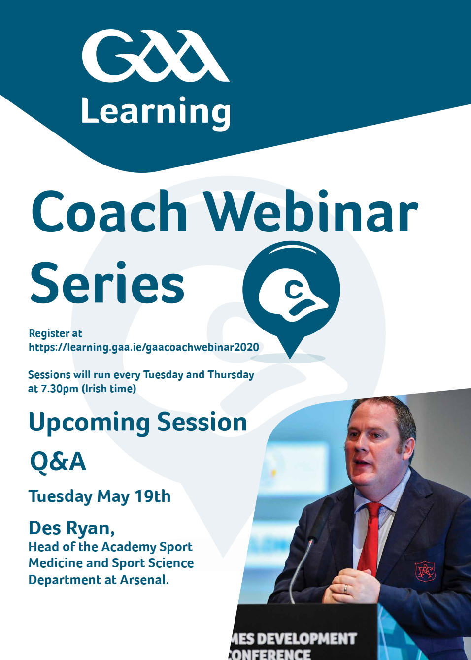

Webinars

Wednesday 20th May:
- 5pm BST:
US Soccer: #SheBelieves Virtual Network: Leading through adversity; Industry Leaders
With Kate Margraf (USWNT General Manager)
Register here for free: https://register.gotowebinar.com/register/3194161949922698000

- 8pm BST:
Donegal GAA: Nutrition principles for training, recovery & performance in young athletes
With Dr Brendan Egan (Associate Professor, DCU)
Register here for free: https://docs.google.com/forms/d/e/1FAIpQLSc2HmGpDhHiHLr-W985MPX-T7cNX5ML4h3ZyPNCeGOHtUySAg/viewform

Webinars

Thursday 21st May
- 10am BST:
St Marys University Twickenham: Performance Football Coaching Webinar
With:
Chris Pocock (Lecturer, Sport & Exercise Psychology)
Ben Bartlett (Head of Coaching, Fulham FC)
Andrew Gillott (Senior Coach Developer, UK Coaching)
Gerry Murphy (Coach & Development Manager, Leinster Rugby)
Ben Knight (U9/U10 Phase Lead, Chelsea FC)
Dan Parker (Performance Analyst, The FA)
Sam Page (U11/12 Head Coach & Digital Player Dev Coach)
Amy Price (Women's National Coach Dev, FA)
Janie Frampton (Ceo, Sports Officials UK)
Register here for free: https://stmarys.zoom.us/webinar/register/9015892052759/WN_5ACzMPnJRqy1a4CUVWaG9g
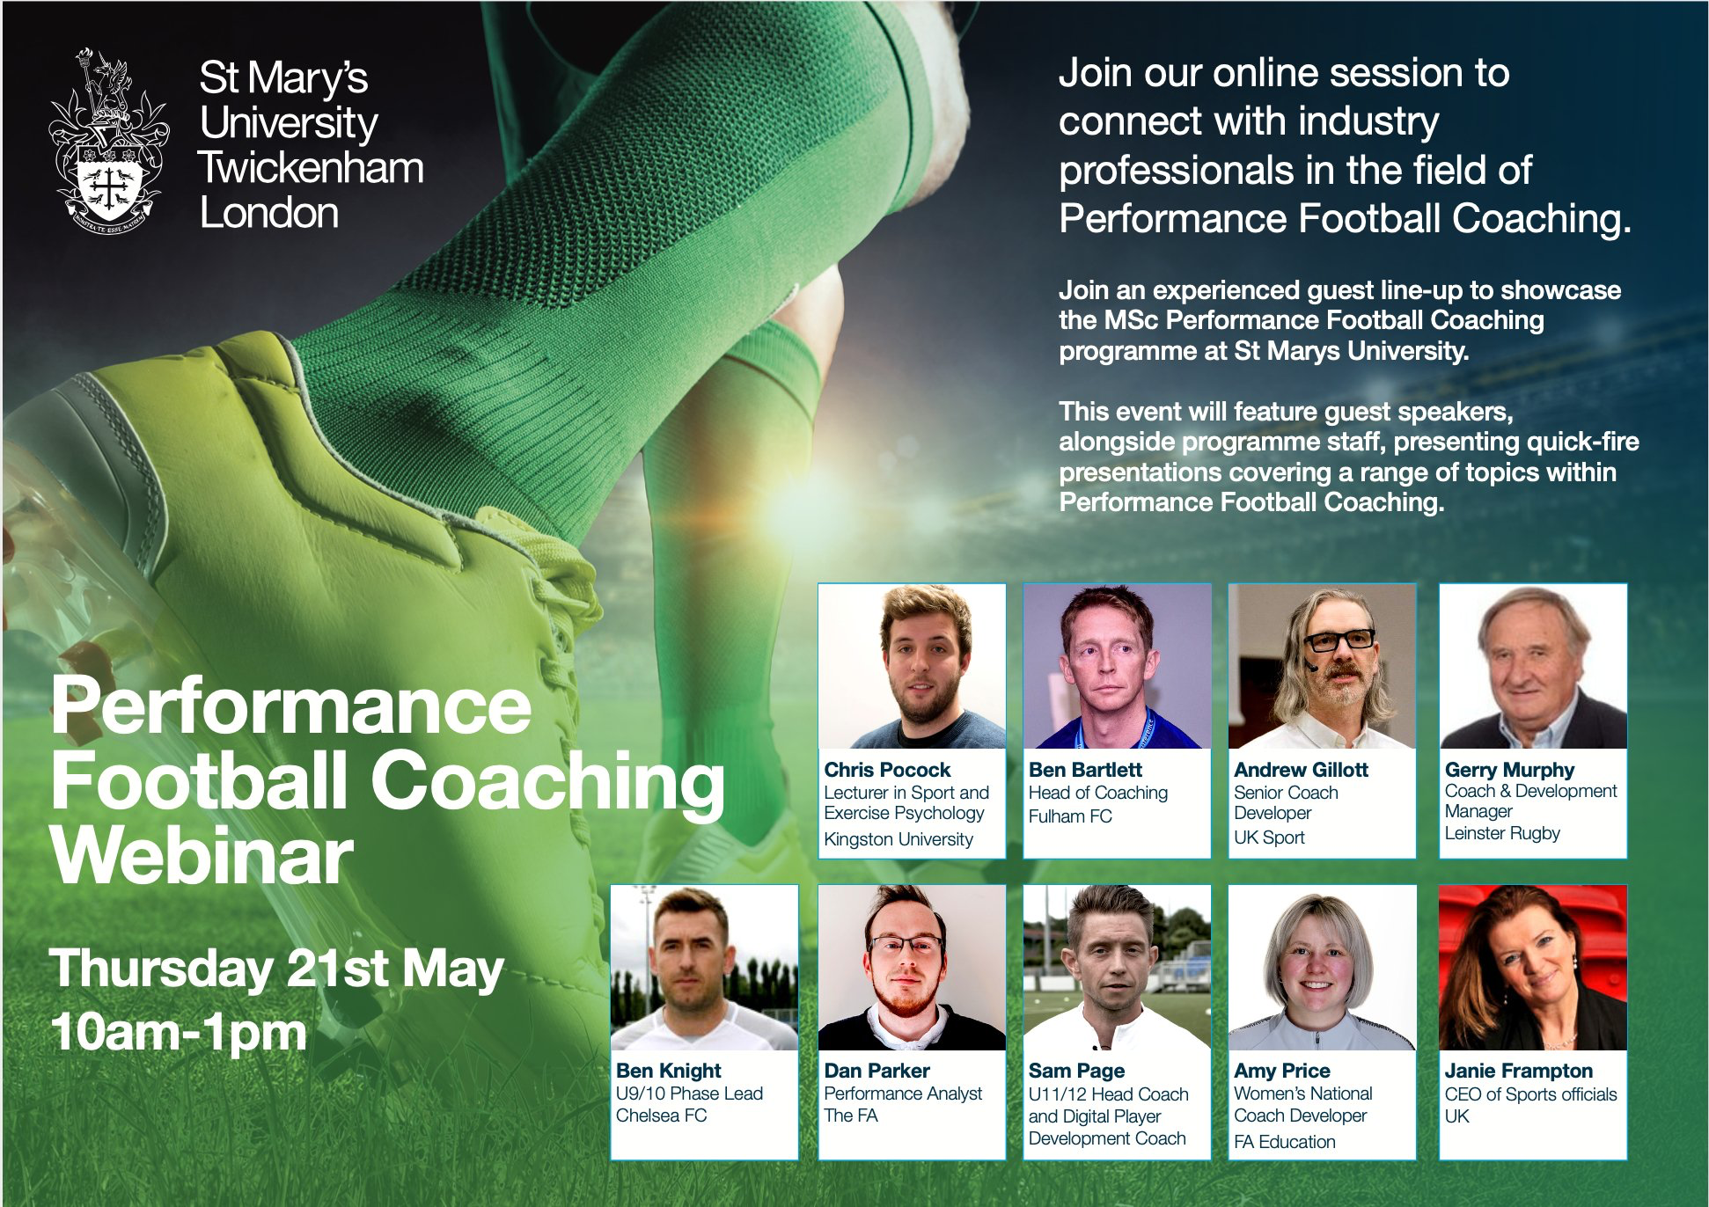

- 12pm BST:
IRFU: Analytica 2020 In aid of Pieta House- Sports Analytics Conference Day 1
Andy Farrell (Ireland Men's Head Coach)
Paul Brand (Man United)
Prof David Sumpter
Colin Byrne (Pro Caddy)
Rhodri Bown (Welsh Rugby Union)
Meaghan Chaykas (Stathletes)
Amber Luzar (GB Hockey)
Mike Hughes (Insight Analysis)
Kate Burke (RFU)
Murray Kinsella (Journalist, The42.ie)
Tom Savage (Three Red Kings)
Jonny Cooper (Dublin GAA)
Johnny Sexton (Ireland Men’s Captain)

Register here for €30: https://www.eventbrite.ie/e/analytica-2020-tickets-105451343808?utm-medium=discovery&utm-campaign=social&utm-content=attendeeshare&utm-source=strongmail&utm-term=listing

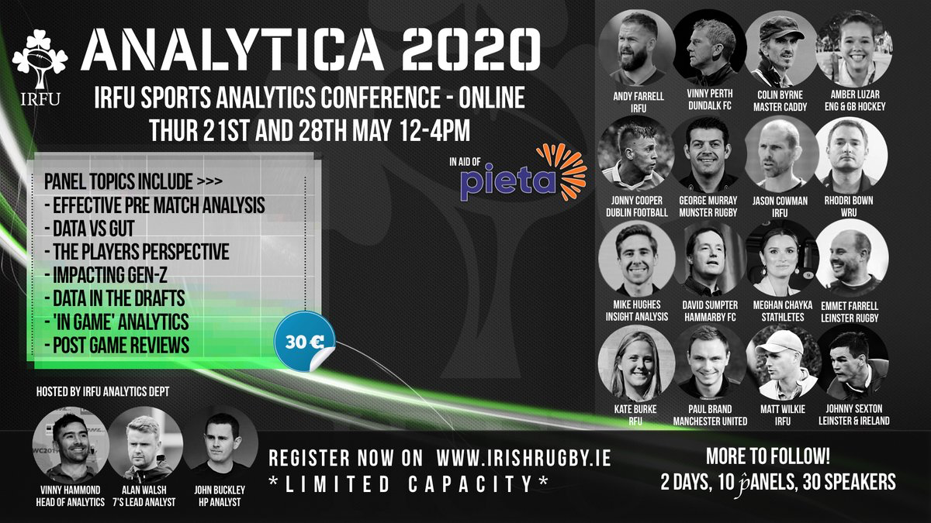

- 1pm BST:
Athletics Ireland: Balancing the scales: The energy cost of training
With Sharon Madigan (Head of Performance Nutrition, Sport Ireland)
Register here for free: https://eventmaster.ie/event/ebKCrKF8x

- 5pm BST:
US Soccer: #SheBelieves Virtual Network: Virtual Classroom Q&A
With Ellie Maybury (USWNT Head of High Performance)
Register here for free: https://ifthenshecan.nepris.com/Sessions/Session/Detail/72574

- 6pm BST:
US Soccer: #SheBelieves Virtual Network: Career Readiness Workshop
With Nataly De La Cruz (US Soccer Employee Experience Manager)
Register here for free: https://attendee.gotowebinar.com/register/644960733598610704

- 7pm BST:
Leinster Rugby: Practical solutions to applying the Tactical Periodisation Model to Rugby
With Mike Ashford (Head Coach, University of Leeds), Brett Igoe (Assistant Coach, Leinster U18s) and Michael Ayers (Lecturer, St Marys University. Chelsea FC Academy Athletic Development Coach))
Register here for free: https://t.co/LSjRO9oYGC?amp=1

- 7pm BST:
UKSCA: Youth S&C Roundtable
Rhodri Lloyd (Cardiff Metro University), Ed Archer (Athlete Academy), Paudie Roche (Arsenal), James Baker (Aspire Academy), Graham Williams (Millfield School), Jamie Salter (York St John University)
Register here for free: https://t.co/IIpYShhVSS?amp=1

- 7.30pm BST:
GAA Learning Portal - Q&A Series
Ciaran Deely PhD (C) - Deely Sport Science

Register here for free: https://learning.gaa.ie/gaacoachwebinar2020

- 8pm BST:
Athletics NI: Anaerobic Speed Reserve
Dr Gareth Sandford (University of British Colombia)
Register here for free: https://athleticsni.org/News/Athletics-NI-News/Athletics-NI-Zoom-In-To-Coach-Development

- 10:30pm BST:
- Apollo V2: The Aussie Dance
John Quinn (Clinical Exercise Physiologist; Sports Performance & Sprints Coach), Darren Burgess (High Performance Manager, Melbourne FC), Paddy Steinfort (Performance Coach, Philadelphia 76ers & Boston Red Sox)

Register here for free: https://zoom.us/webinar/register/WN_aCi1gw_RRYKj-KHw5-vx0Q

Webinars

Friday 22nd May

- 3pm BST:
MSA Ireland: Building an evidence-based youth football development programme
Jorg van der Breggan & Jan Verbeek (Dutch FA)

Register here for free: https://twitter.com/MSAIreland

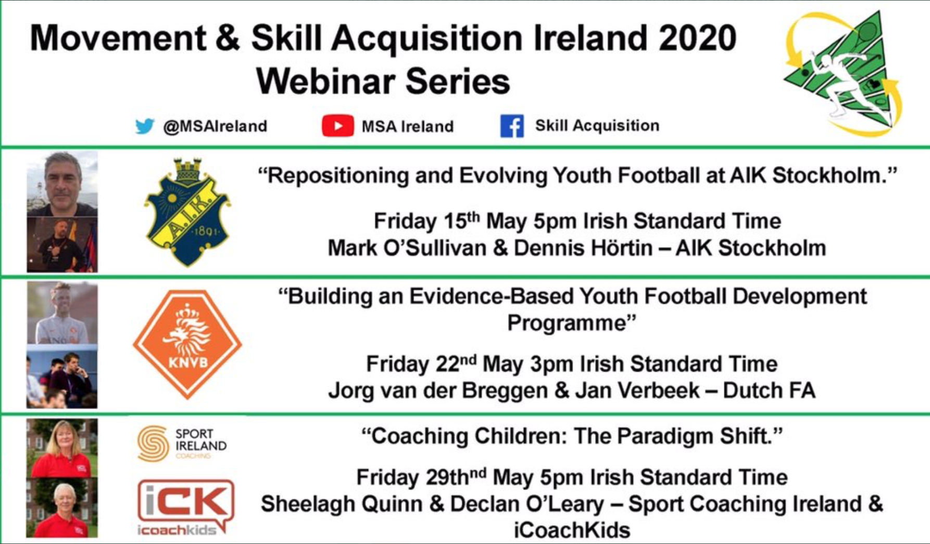

Webinars

Saturday 23rd May
- 3pm BST:
#LTADChats: Bridging the gap between research and practice
Prof Ben Jones & Prof Kevin Till (Leeds Beckett)

Register here for free: https://ironmanperformance.org/ltadchat-live

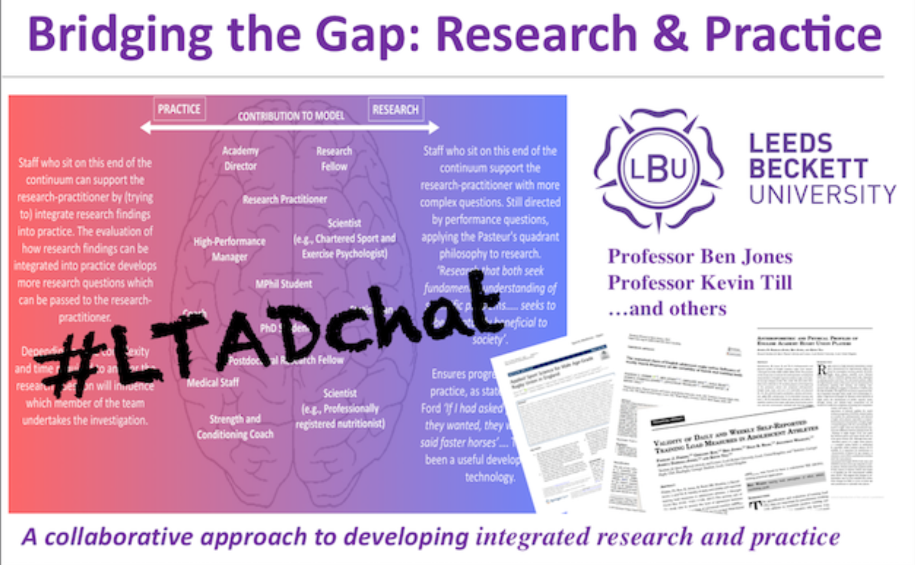

Webinars

Sunday 24th May
- 11pm GMT:
The S&C Pathway 2020 Webinar: Career in S&C - Organised by Chris Epakis

Ron McKeefery (Fresno State Football - Assistant Athletic Director of Sports Performance)
Dr. Adam Beard (Chicago Cubs - Director of High-Performance)
Julian Jones (Australian Institute of Sport - Performance Service Manager)
Jarrod Wade (South Sydney Rabbitohs - Head of High Performance)
Kevin Geary (Bristol Bear - Head of Athletic Performance)
Ryan Whitley (Brisbane Broncos - Strength and Power Coach)
Dr. Michael Rennie (Sydney Swans - Conditioning Coach)
Dr. Steve Kelly (Sydney Swans - Academy Head Strength and Conditioning Coach)
Janina Strauts (Olympic Winter Institute of Australia - Physical Preparation Coach)
Jack Milligan (South Sydney Rabbitohs - Strength and Power Coach)
Kellyanne Redman (Brisbane Broncos - Assistant Strength Coach)

Register here - https://www.eventbrite.com.au/e/the-sc-pathway-2020-international-webinar-series-i-tickets-94269922877

