Webinars

Monday 11th May
- 1pm BST:
ACSM Combat Sports Conference Day 2
Hosted by Mark Germaine (Nutritionist with Dublin GAA & ACSM Combat Sports Chair) via Zoom. With:
Tim Trevail (PhD C): Managing Workload for Injury reduction & performance enhancement
Chris Kirk (PhD C): The training characteristics, loads & effect of mixed martial arts
Dr Lewis James: Putting things back together after the cut, considerations to maximise recovery after rapid weight loss
Joe Matthews (PhD C): A historical look at making weight in combat sports, have we moved forward?
Louis Bloor (British Judo): Successes & failings in weight making, the struggles of trying to change culture & weight management in judo/wrestling vs boxing & TKD
Dr Scott Forbes: Creatine supplementation: Practical Strategies & considerations for MMA
Dr Matteo Capodaglio: Differences between weight management protocols in combat sports
Aaron Varga: Balance & the brain: The long-term effects of repetitive head impacts on postural stability

Register here for free (https://t.co/nQGY4nxPQc?amp=1)

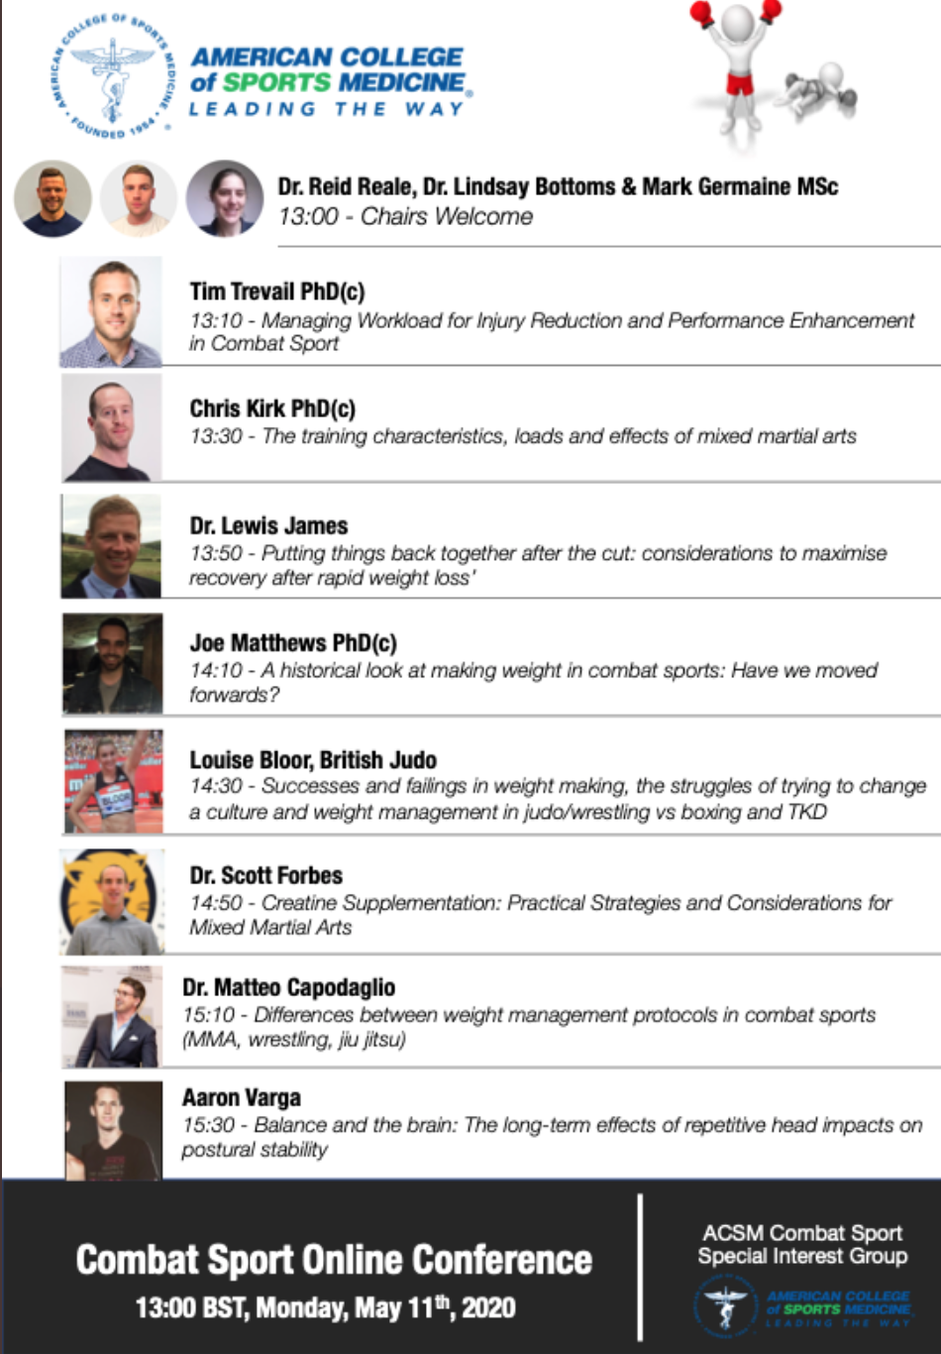

- 1pm BST:
Hockey Ireland: Video Analysis as a Coaching Tool
With Gareth Grundie (Irish Women’s Team Asst. Coach) and Shirley McCay (Irish Women’s International)
Register here for free: (http://www.hockey.ie/coachingwebinars)

- 7.30pm BST:
Kildare GAA: Nursery Workshop
With David Murphy and Mark Fitzharris
Register here for free: (https://forms.office.com/Pages/ResponsePage.aspx?id=hrxFrNSvpUKfwz6H4bd_zjI3NlW9Wp9Ggw6Wgc-U4ZpUQ05IUTU0UUlSRzJENElESzFKV1JaSVdSTC4u)

- 8pm BST:
Offaly GAA: Systems of Play for Gaelic Football
With Paul Garrigan. Register here for free: https://t.co/fRW0ZR980o?amp=1

Webinars

Tuesday 12th May
- 3am BST:
British Columbia Rugby: Ladies Who Lead Series
With Lesley McKenzie (Head Coach, Japan Women’s 15s)
Register here for free: (https://us02web.zoom.us/meeting/register/tZUlc-GorD0qH9EqfZCoF1pLdPmPyYcv4fwq?timezone_id=Europe%2FDublin)

- 9.30am BST:
Sports MAP: Hamstring Prevention
With Johan Lahti PhD(c) (University of Nice).
Register here for free:(https://us02web.zoom.us/webinar/register/WN_f28SaaUwR92Yh5u9sEkDBQ)

- 7pm BST:
England Rugby: Knowing Yourself as a Coach
With Simon Amor (England Attack Coach & GB 7s Coach)
Register here for free: (https://t.co/lWc0iL5OQ5?amp=1)

- 7.30 BST:
GAA Learning Portal: Q&A Series
With Prof Eamonn O’Shea (Former player, coach & manager, Tipperary Hurling)
Register here for free: (https://learning.gaa.ie/gaacoachwebinar2020)

Webinars

Wednesday 13th May:
- 12pm BST:
Speed Works: Coaching Eye (Acceleration Mechanics)
With Jonas Dodoo (Consultant Sprint Coach, International)
£30 charge, register here: https://t.co/CQzcah2nkT?amp=1

- 3pm BST:
BASES Webinar Series: The art and science of using research to inform applied sport science in team sports
With Dr Jon Bartlett (Associate Professor, Bond University and Research Fellow, Victoria University).
Register here for free (https://bases-live.workbooks.com/process/1QDN0UTM/event_management?id=384&page=select_tickets)

- 7pm BST:
UKSCA: Speed Training Roundtable
With Rich Clarke (UKSCA),
JB Morin (Universite Cote d'Azur)
Jared Deacon (Scottish Rugby)
James Wild (Surrey Sports Park)
Nick Winkleman (IRFU)
Paul Caldbeck (LJMU)
Damian Harper (University of Central Lancaster)
Register here for free (https://survey.sogosurvey.com/survey.aspxk=SsRRSPQsXPsPsPsP&lang=0&data=)

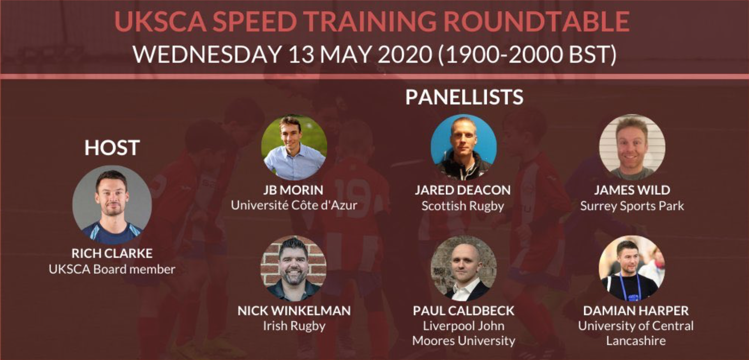

- 8pm BST:
Offaly GAA: Culture & Coaching in the GAA
With Michael Fennelly (Manager, Offaly Senior Hurlers)
Register here for free (https://t.co/fRW0ZR980o?amp=1)

Webinars

Thursday 14th May

- 4pm BST:
US Soccer: High Performance Webinar Series
Supporting the Female Athlete
4pm-6pm: Youth development considerations to senior player performance with Ellie Maybury (WNT Performance Coach) & Julian Haigh (WNT Sport Scientist).
7pm-9pm: Considerations on preparation to performance with Steve Stricker (WNT Head Athletic Trainer) and Carlos Jimenez (WNT Physical Trainer).

- 7.30pm BST:
GAA Learning Portal: Q&A Series
With Shane Mangan (Performance Analyst with Dublin GAA)
Register here for free: https://learning.gaa.ie/gaacoachwebinar2020

