Webinars

Tuesday 28th April
- 7am BST:
VALD Performance: Accelerating performance for game demands (Live Q+A)
David Howarth: Connacht Rugby
Blake McLean: University of Technology Sydney
Dr Billy Hulin: St George Illawara Dragons RLFC and University of Wollongong
Register here: http://win.valdperformance.com/register-online-series/

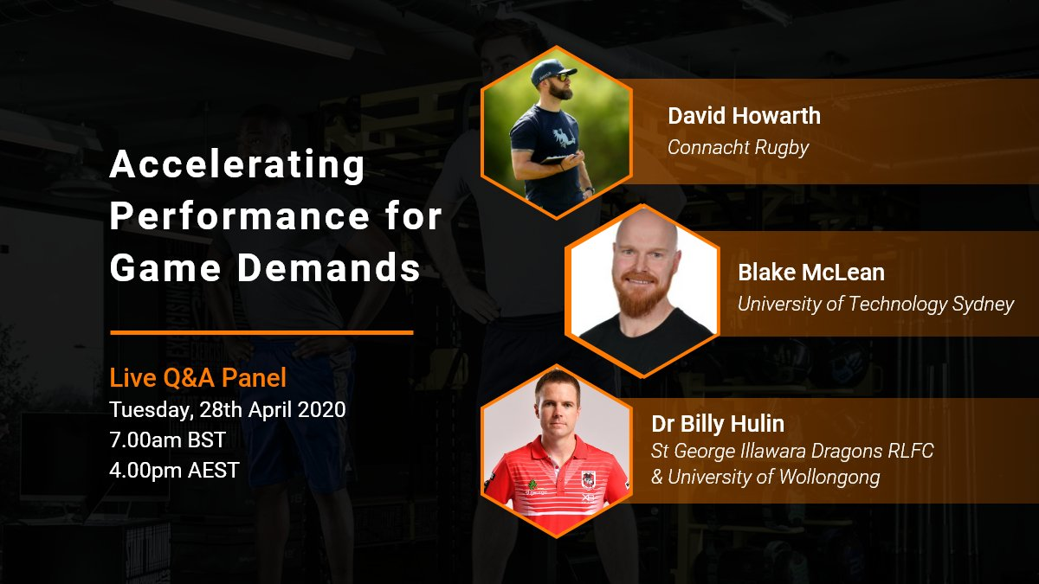

- 7pm:
England Rugby: "Refereeing the tackle" with international referees Ian Tempest & Christophe Ridley. Register here https://t.co/RaU8tz5puA?amp=1

- 7.30pm:
GAA: "Becoming a better coach" with Wade Gilbert (Prof of Kinesiology at California State University). Register here https://learning.gaa.ie/gaacoachwebinar2020

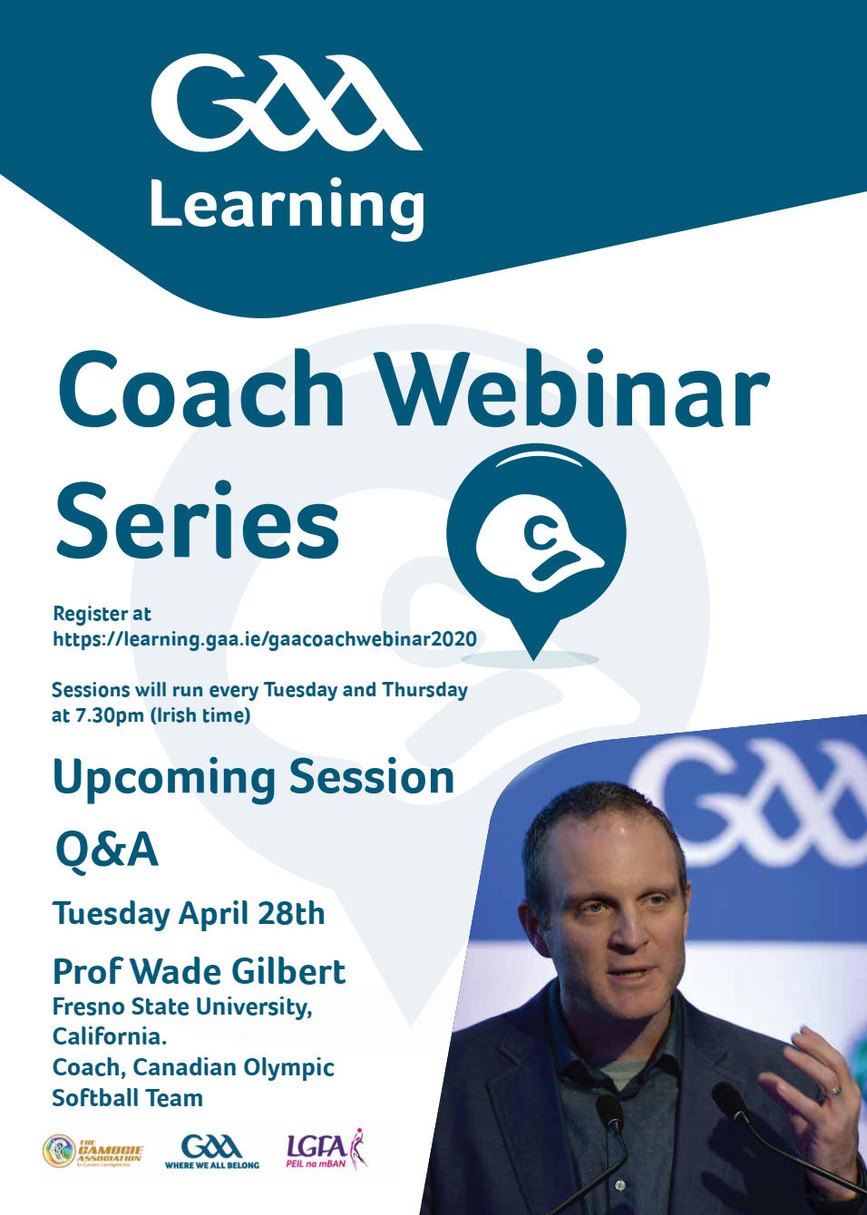

Webinars

Wednesday 29th April:
- 3am:
STATSport: “From Match Day to Training: Replicating Match Intensity” with Brett Smith (Auckland Blues), Jordan Cassidy (Hong Kong Rugby) Davie Gray (Hurricanes Rugby) and Paul Devlin (Brisbane Broncos).
Register here: https://statsports.com/webinar-series/

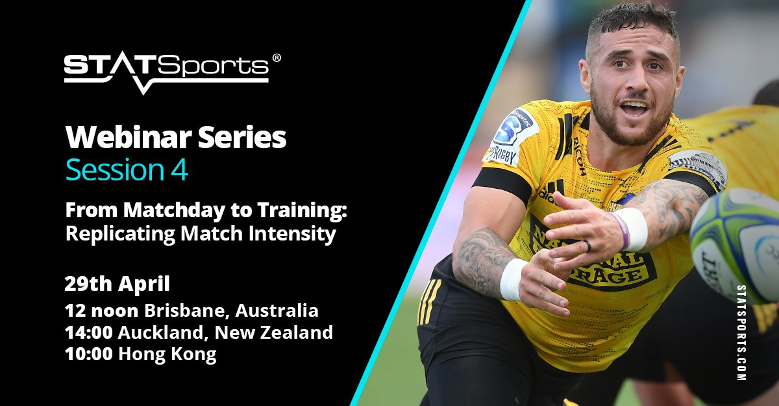

- 7am - 1.30pm:
The Sports MAP Network: Mastering lower limb muscle injuries
Co-hosted by Michael Giakumis - British Athletics
7am: Martino Franchi - Muscle architecture and its functional impact
7.30am: Paul Head - Optimising healing in the initial 48hours
8am: Charles Pedret - Imaging and Injury classification
8.30am: Nicol Van Dyk - Risk and prevention, the pathway and process
8.55am: Natalia Bittencourt - The complex systems approach and risk identification
9:30am: Fionna MacPartlin - Principles of loading during muscle rehab
10am: Craig Purdam - Rehab of intramuscular injuries
10:30am: Bryan Heiderscheit - Hamstring rehab

11am: James Moore - Hamstring case study
12pm: Andy Walling - Calf strain case study in endurance athlete
12:30pm: Tim Parham - Quadricep strain case study in the kicking athlete
1:00pm: Stephen McAleer - Quadricep strain case study in the sprinting athlete

Register here for free: https://sportsmap.com.au/mastering-lower-limb-muscle-injuries/
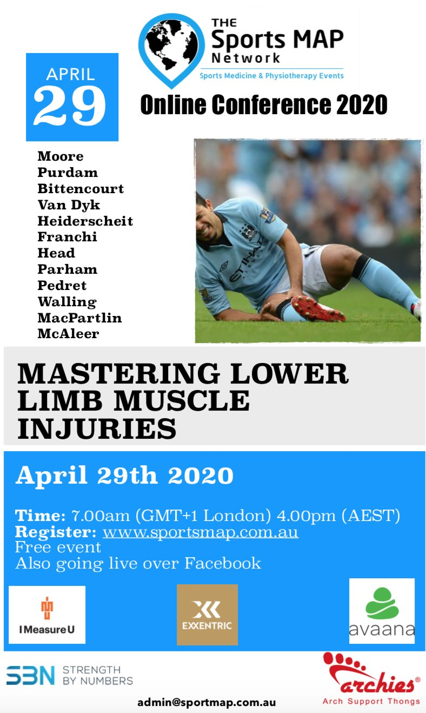

Webinars

Thursday 30th April
- 1.35pm – 8.30pm:
Online Sports Nutrition Conference for Covid Relief, hosted by Charles Ashford (Director of Sports Nutrition, University of North Texas).
1.35pm: Emma Tester (Performance Nutritionist at Munster Rugby): The Impact of Dietary Intake on Immune Function. Considerations for Team Sports
2pm: Dan Martin (Post-Doctoral Researcher at Liverpool John Moores University): Using Behavior Change Science to Inform Performance Nutrition Interventions in Professional Sport
2.35pm: Pratik Patel (Director of Performance Nutrition & Assistant S&C at New York Football Giants): Sports Nutrition: From College to the Pros (Reflective Session)
3.10pm: Gemma Sampson (Sports Nutritionist for Team Dimension Data for Qhubeka Men's Professional Cycling): Carbohydrate for Endurance Athletes in Competition: Assessing Knowledge and nutritional Practice
3.55pm: James Morehan (Performance Nutritionist at the England Football Association): Nutrition for Boxing and Making Weight Safely
4.30pm: Matt Jones (Performance Nutritionist at West Ham United Football Club): Carbohydrate in Soccer: Research & Realities
5:05pm: Carl Langan-Evans (Post-Doctoral Researcher at Liverpool John Moores University): Making Weight Safely in Combat Sports: Lessons Learned from the Labs & Field
5.50pm: Patrick Wilson (Director of Human Performance Lab at Old Dominion University): The Athlete’s Gut: Prevalence, Causes, and Remedies
6.25pm: Ted Munson (Performance Nutritionist at Harlequins Rugby Club): Practical Nutrition Applications in Elite Rugby
7.10pm: Nessan Costello (Performance Nutritionist at Leeds United Football Club): Nutrition for Collision Sports
7.55pm: Brett Singer (Sports Dietitian at Houston Dynamo Football Club) : Return to Play: Nutrition for the Injured Athlete
8.30pm:Ryan Jackson (Director of Performance Nutrition at Southern Methodist University): Combining the Role of Sports Dietitian and Strength & Conditioning Coach
9.05pm: Marc Bubbs (Performance Nutritionist at Canada Basketball): Lessons from the Hardwood: Performance Nutrition in Practice

- 4pm:
US Soccer High Performance Webinar: Layering Data Sets and Building Visualizations, Julian Haigh (US Soccer WNT & MWSL Sport Scientist)
Register here for free: https://www.ussoccer.com/bendthecurve/webinars

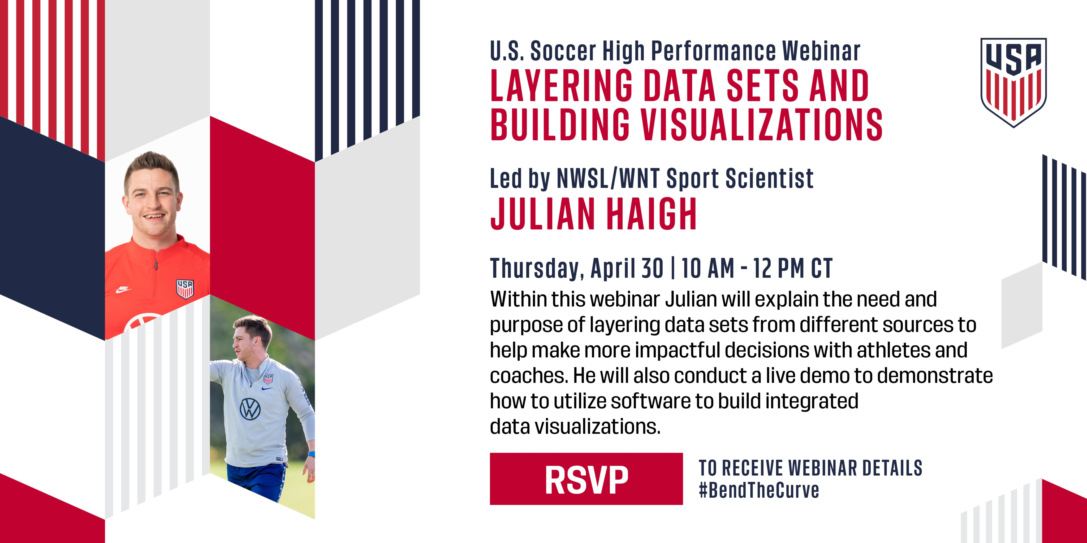

- 5pm:
Just Fly Sports - Speed Gate Golf with Sam Portland
Purchase here: https://www.just-fly-sports.com/product/speed-gate-golf/

- 7pm:
Athletics Ireland: Coaching Process with Niamh & Noel Richardson (Middle Distance Coaches, Kilkenny City Harriers). Register here for free: https://eventmaster.ie/event/pZmuvyTyo

- 7.30pm:
GAA: Presentation from Johnny Bradley (Topic TBC). Register here for free https://learning.gaa.ie/gaacoachwebinar2020

Webinars

Friday 1st May
- 9am-4.30pm:
Staffordshire University Clinical Biomechanics Department: 18th Annual Clinical Biomechanics Conference Day 1.
9.10am: Sharon Dixon (University of Exeter) - Using biomechanical analysis to support military and elite sporting populations
10.05am: Paul O Malley (Profeet) - The performance enhancing effect of running footwear: Evolution or Revolution?
10:35-10:50 Jeong-Ro Lee et al. (Loughborough University) - Optimisation of a football boot bottom
11.15am: Professor Hazel Screen (Queen Mary University of London) - Achilles tendon - Engineering approaches to exploring injury
12.10am: Professor Costis Maganaris (Liverpool John Moores University) - Joint & Muscle-Tendon Mechanics in Children with Cerebral Palsy
1.40pm: Dr Anita Williams (University of Salford) - Perceptions of the role of footwear – identity versus foot health?
2.10pm: Christopher G. Tompkins et al. (University of Nottingham; Adidas America) - Dual optical force plate for time resolved measurement of forces and pressure distributions beneath shoes and feet
2.25pm: Matt Hill et al. (Staffordshire University) - A systematic review of the effectiveness of therapeutic footwear for children with mobility impairment
2.40pm: Adri Hartveld et al. (Healus Ltd.; Staffordshire University) - RESILIC sole construction – the evolution of the revolution
3.20pm: Nina Davies (Leeds Community Healthcare NHS Trust) - Gait deviations in young children - what raises concern?
3.50pm: Abdullah Alzahrani et al. (University of Dundee; Shaqra University) - Gait analysis in conjunction with neural network for prediction and diagnosis of patients with stroke
4.05pm: Renan Monteiro et al. (University of Sao Paulo) - Foot muscle strength can be improved in people with diabetic polyneuropathy: A preliminary study.
4.20pm: Gayathri (Victoria) Balasubramanian et al. (Staffordshire University) - The effect of controlling plantar skin temperature on the measures of post-occlusive reactive hyperaemia

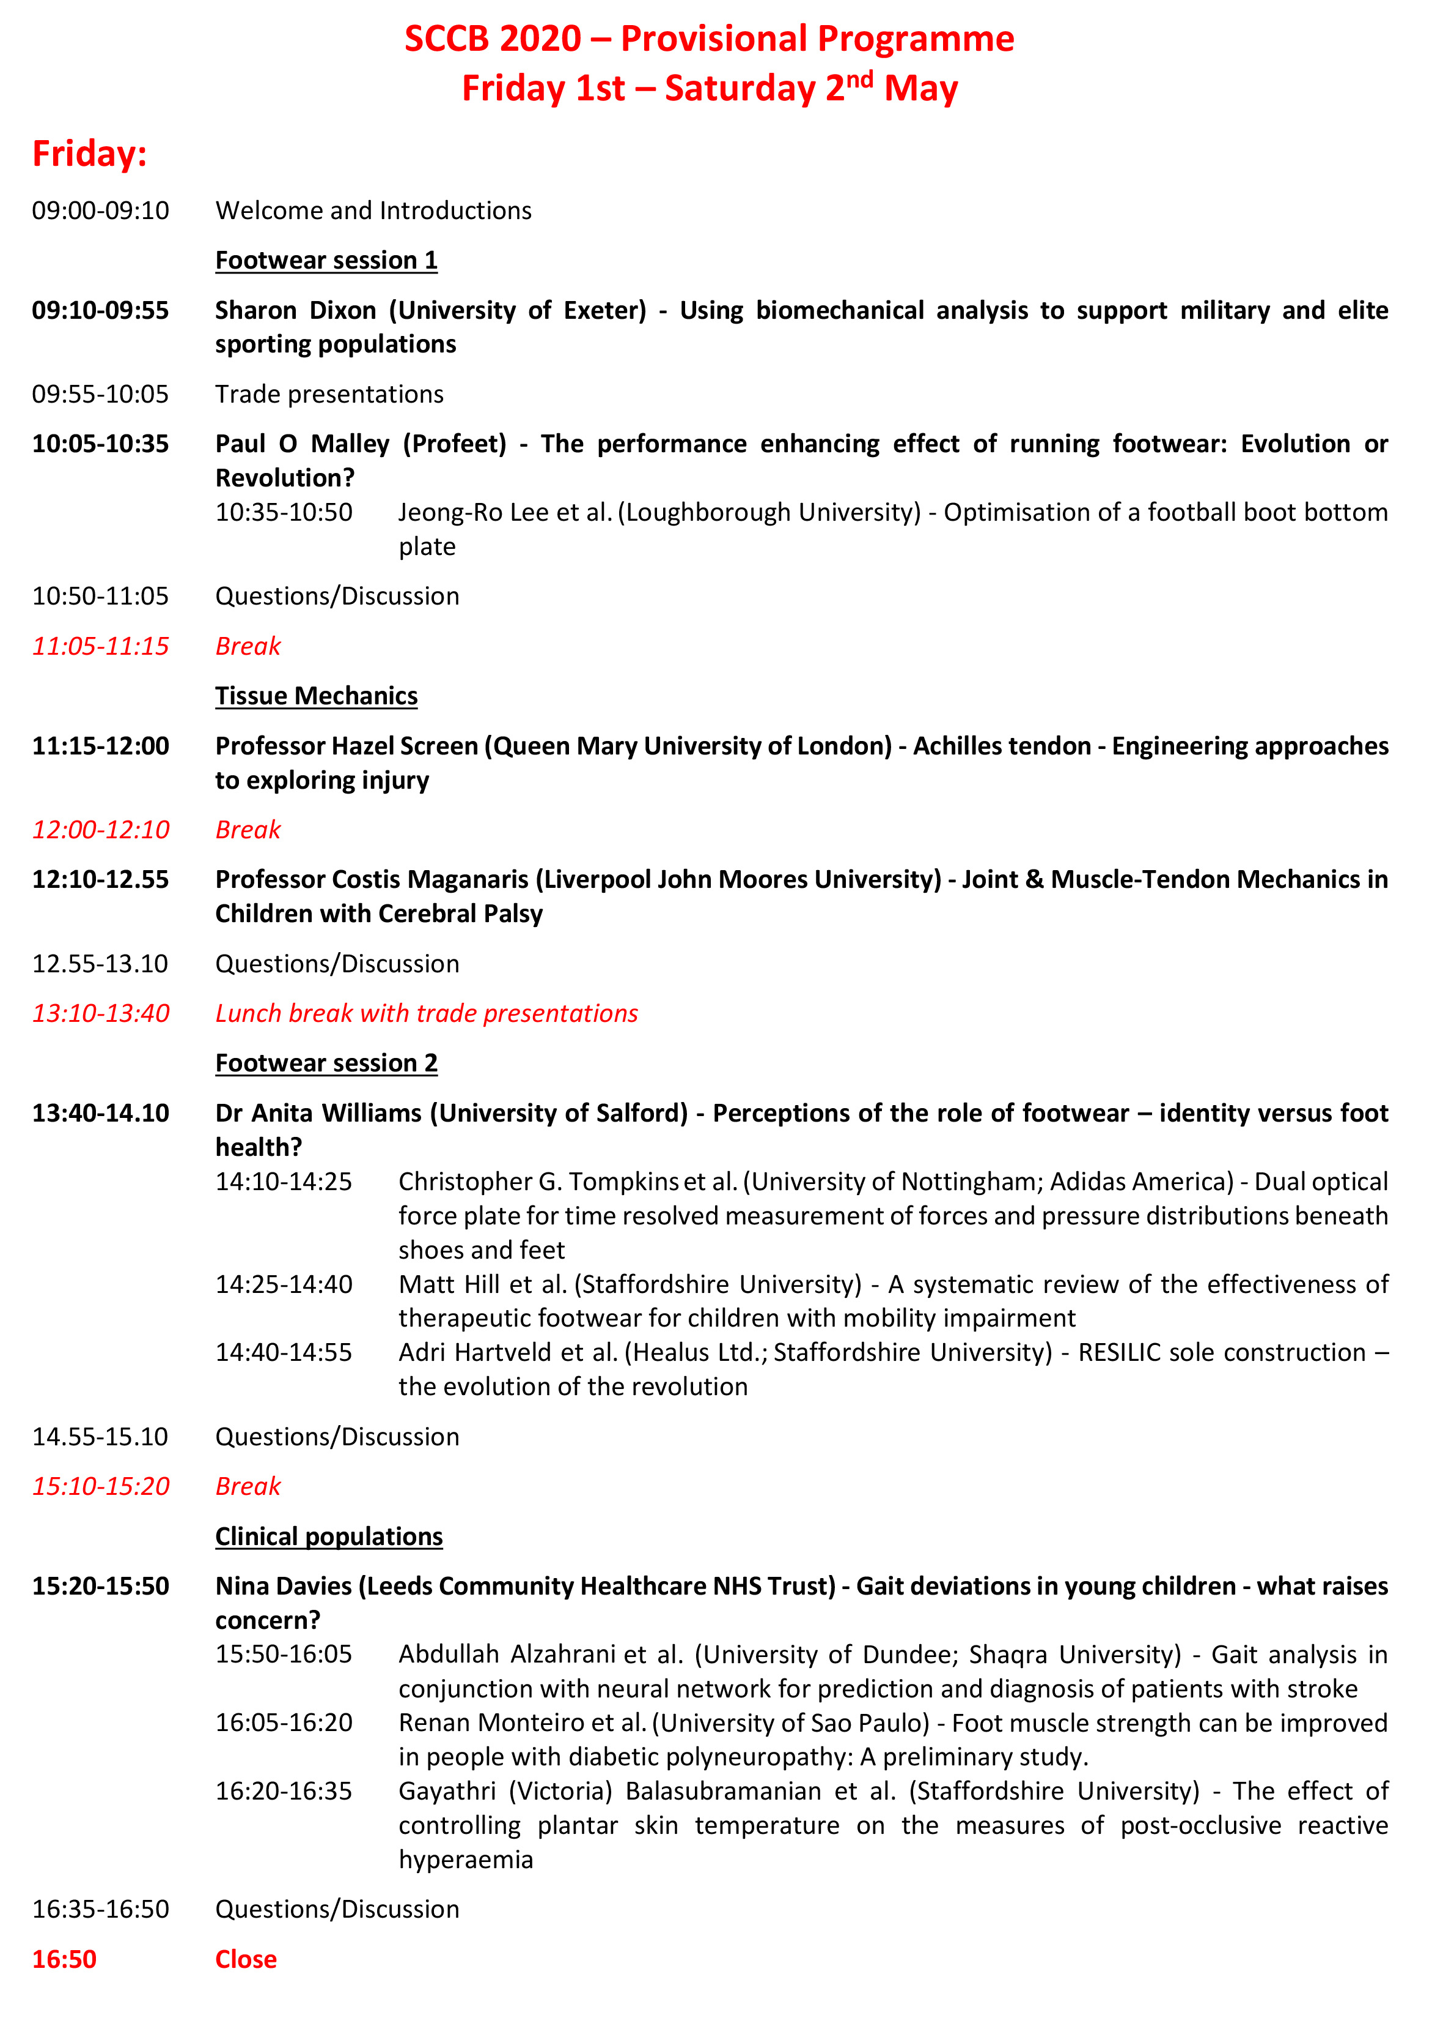

- 12pm:
UK Coaching: Unlocking coach potential: Maximizing your effectiveness with Suzanne Brown (Sports Psychologist, Arsenal FC) and Andy Bradshaw (UK Coaching). Register here for free https://www.trybooking.com/uk/book/event?embed&eid=11665

Webinars

Saturday 2nd May
- 9am-4.30pm:
Staffordshire University Clinical Biomechanics Department: 18th Annual Clinical Biomechanics Conference Day 2
09:00-09:45: Michael Rexing (Human Study AV.) - Efficient walking in neuromuscular lower limb orthotics through kinetic energy conversion
09:45-10:00: Natalie Vanicek et al. (University of Hull; University of York; Nottingham Trent University; University of Salford; Lancashire Teaching Hospitals NHS Foundation Trust; Hull University Teaching Hospitals NHS Trust; Public Involvement Member) - A randomised feasibility study of self-aligning prosthetic device for older patients with vascular-related amputations: The STEPFORWARD study
10:20-11:05: Dr Andy Franklyn-Miller (SSC Sports Medicine) - Controversies in biomechanically driven gait re- education for lower limb injury
11:15-11:45: Tom Kepple (C-Motion, Inc.) and Steven Cadavid (Kinatrax, Inc.) - Markerless Motion Capture for in Game Baseball Biomechanics Analysis
12:10-12:25: Hill, K.J. et al. (University of Dundee) - Does a left footed or right footed reverse stick hit in hockey cause a greater force to be exerted through the lower limb joints?
12:25-12.40: Turnbull, E.J. et al. (University of Dundee) - The influence of pelvic factors on perceived discomfort in female cyclists
12.40-12.55: Harrison, R.P. et al. (University of Dundee) - The importance of jump direction in knee injury prevention in volleyball.
13.40-14.10: Nicola Eddison et al. (The Royal Wolverhampton NHS Trust; Staffordshire University) - The effect of tuning ankle foot orthoses-footwear combinations on the gait kinematics of children with cerebral palsy and the effect of user perception on adherence: a case series
14:25-14:35: Jessica Hargreaves et al. (Opcare) - The effect of a thoracolumbar brace under different conditions on spinal kinematics in a group of healthy adults during level walking: A pilot study
14.35-15.05: Dr Alfred Gatt (University of Malta) - Pressure and temperature mapping in diabetic foot disease
15:05-15:20: Andrei L. Perez Olivera et al. (London South Bank University) - Neuromuscular electrical stimulation training of an intrinsic foot muscle: what stimulus intensity should be used?
15:20-15:35: David Allan et al. (Staffordshire University) - Skin Microcirculation: A comparison between imaging Photoplethysmography and Laser Speckle Contrast Analysis

15:50-16:05: Christopher Aitkins et al. (South Tees Hospitals NHS Foundation Trust) - Sensor placement for assessing muscle activity of the foot
16:05-16:20: Elsayed, A. et al. (University of Dundee) - Relationship between operating table height and lumbar spine kinematics.
16:30 Closing Remarks

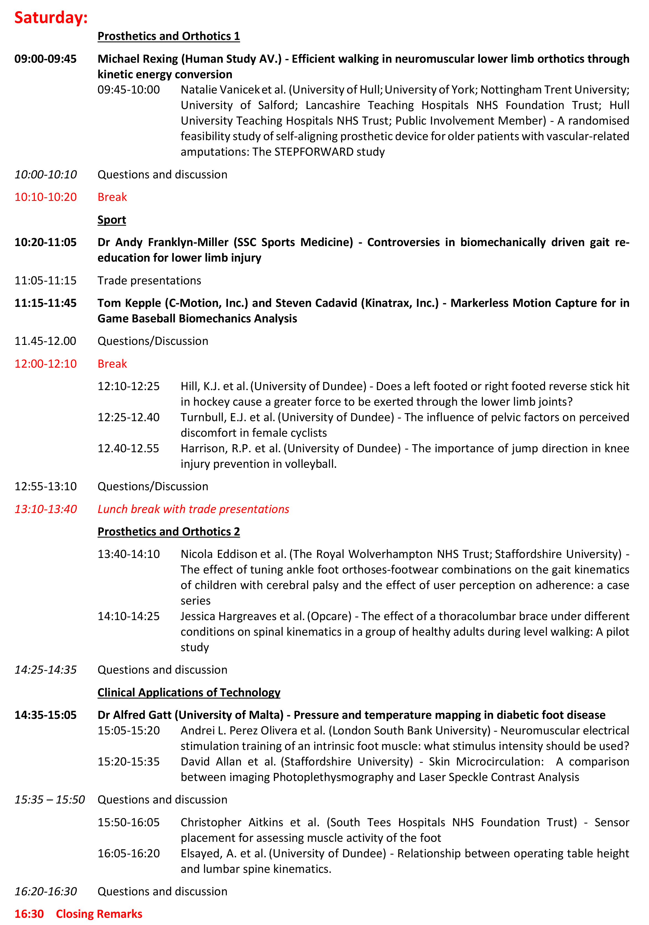

- 3pm:
#LTADChats hosted by Joe Eisenmann: Training Load in Youth Athletes with Ben Jones (Leeds Beckett), David Johnson (Sport Scientist, AFC Bournemouth Academy), Jay Salter ( PhD Researcher) and Andy Bruce (Statera). Watch here for free https://zoom.us/j/697756513

